

|  |
| --- |
| **Network Infrastructure**  **ACME Inc. Network Evaluation**  **Snow White**  CMP314: Computer Networking  BSc Ethical Hacking Year 3  2024/25 |

*Note that Information contained in this document is for educational purposes.*

Contents

1 Introduction 1

1.1 Background 1

1.2 Aims 2

2 Network Mapping 3

2.1 Network Diagram 3

2.2 Routing Table 4

2.3 Subnet Table 5

2.4 Port Table 6

3 Network Mapping Process 9

3.1 Router 1 – 192.168.0.193/27 11

3.1.1 Web Server 1 – 172.16.221.237/24 13

3.1.2 PC 1 – 192.168.0.210/27 19

3.2 Router 2 – 192.168.0.226 22

3.2.1 PC 2 – 192.168.0.34/27 24

3.2.2 PC 3 – 13.13.13.13/24 30

3.3 Router 3 – 192.168.0.230 32

3.3.1 PC 4 – 192.168.0.130/27 34

3.4 Firewall - 192.168.0.240/30 36

3.4.1 Web Server – 192.168.0.242/30 41

3.5 Router 4 – 192.168.0.97/27 43

3.5.1 PC 5 – 192.168.0.66/27 46

4 Security Weaknesses 49

4.1 Routers 49

4.1.1 Default Credentials 49

4.1.2 Telnet 49

4.2 Computers 49

4.2.1 Weak Passwords 49

4.2.2 Password Reuse 50

4.2.3 No Lockout Policy 50

4.2.4 SSH Brute Forcing 50

4.2.5 NFS Privileges 51

4.2.6 Misconfigured Superuser Permissions 51

4.3 Servers 51

4.3.1 Out Of Date WordPress Version 51

4.3.2 Out of Date Apache Version 51

4.3.3 Shellshock 52

4.4 Firewall 52

4.4.1 Default Credentials 52

4.4.2 HTTP vs HTTPS 52

5 Discussion 53

5.1 Evaluation of Network 53

5.1.1 Topology 53

5.1.2 Routing 53

5.1.3 Subnetting 53

5.1.4 Components 54

5.2 Further Work 54

6 Conclusions 56

7 References 57

Appendices 58

Appendix 1 Subnetting Working 58

Appendix 2 Dirb Scan 61

Appendix 3 Nikto Scan 64

Appendix 4 WPScan 65

Appendix 5 Metasploit 67

Appendix 6 NMAP Scans 69

# Introduction

## Background

Due to advances in technology , network security is more important now than it has ever been before. Attacks on networks are becoming more and more sophisticated, and the only hope for the victims is that they can keep their defenses up to date and respond to new techniques as fast and efficiently as possible. The number of DDoS attacks have increased dramatically over the past 5 years, they went from 8 million in 2018 to 16 million in 2023 (Staff, 2022). This increase can be viewed in the graph , in Figure 1 below.

Due to this increase , companies and organisations need to take their cyber security very seriously, it can no longer be ignored. Ignoring cyber security can lead to millions of pounds being lost in revenue and/or fines due to cyber-attacks that could cause outages or in deploying ransomware.

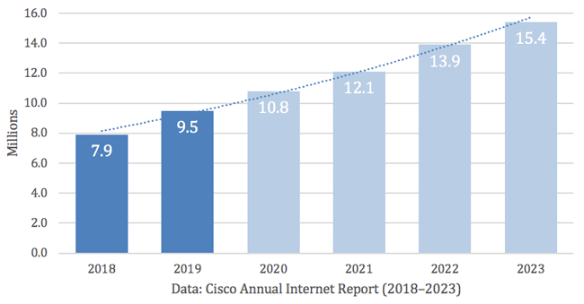Figure 1 – DDoS Attacks for the last 5 years from Cisco

ACME Inc., have recently parted ways with their network manager in what has been referred to as “acrimonious circumstances”. When they went to retrieve crucial network documentation, they found that no such work had been produced. Due to this, the company management has raised concerns relating to the state of their network and are crucially concerned about its security.

Due to this the client has approached a network tester to analyze the network and produce the documentation as well as test the network for any vulnerabilities. The client has provided the tester with a Kali Linux Machine using the credentials(root/toor) with the aim of testing their network using the tools available to them on the Kali machine.

These tools are:

* Drawio – for the network topology diagram
* Dirb – a tool for directory enumeration against websites
* Nmap – a network mapper
* Firefox – a web browser
* Metasploit -an exploit framework
* Nikto – a vulnerability scanning tool that targets servers
* WPScan – is a command line security scanner for WordPress Sites

## Aims

The aim of this report is to:

* To create a detailed network topology diagram that shows all the devices in use on ACME Inc network, their IP addresses, subnets, subnet masks and interfaces used.
* Have a table of used ports on all present devices on the network.
* Produce a subnet table of the subnets used in the network
* Evaluate the security of the network and suggest any countermeasures for any identified vulnerabilities.
* Evaluate the design of the network.
* Provide thorough documentation like this report of the assessment process so it can be reproduced.

# Network Mapping

## Network Diagram

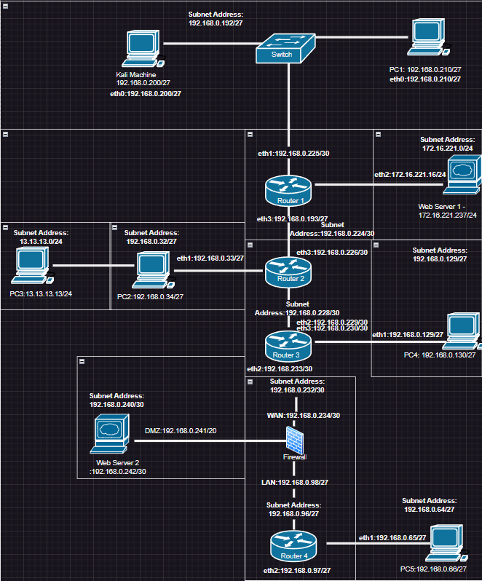

## Routing Table

|  |  |  |  |  |  |  |
| --- | --- | --- | --- | --- | --- | --- |
| Device | Interface | Subnet Address | Subnet Mask | IP Address | Default Gateway | Broadcast Address |
| Router 1 | Eth1 | 192.168.0.224/30 | 255.255.255.252 | 192.168.0.226 | 192.168.0.225 | 192.168.0.228 |
|  | Eth2 | 172.16.221.0/24 | 255.255.255.0 | 172.16.221.237 | 192.168.0.193 | 172.16.221.255 |
|  | Eth3 | 192.168.0.192/27 | 255.255.255.224 | 192.168.0.200  192.168.0.210 | 192.168.0.193 | 192.168.0.223 |
| Router 2 | Eth1 | 192.168.0.32/27  13.13.13.0/24 | 255.255.255.224  255.255.255.0 | 192.168.0.34  13.13.13.12  13.13.13.13 | 192.168.0.33 | 192.168.0.63  13.13.13.0 |
|  | Eth2 | 192.168.0.228/30 | 255.255.255.252 | 192.168.0.229 | 192.168.0.229 | 192.168.0.231 |
|  | Eth3 | 192.168.0.224/30 | 255.255.255.252 | 192.168.0.226 | 192.168.0.233 | 192.168.0.227 |
| Router 3 | Eth1 | 192.168.0.128/27 | 255.255.255.224 | 192.168.0.233 | 192.168.0.233 | 192.168.235 |
|  | Eth2 | 192.168.0.232/30 | 255.255.255.252 | 192.168.0.233 | 192.168.0.233 | 192.168.0.235 |
|  | Eth3 | 192.168.0.228/30 | 255.255.255.252 | 192.168.0.230 | 192.168.0.230 | 192.168.0.231 |
| Router 4 | Eth1 | 192.168.0.64/27 | 255.255.255.224 | 192.168.0.66 | 192.168.0.65 | 192.168.0.95 |
|  | Eth2 | 192.168.0.96/27 | 255.255.255.224 | 192.168.0.97 | 192.168.0.97 | 192.168.0.127 |
| Firewall | WAN | 192.168.0.232/30 | 255.255.255.252 | 192.168.0.234 | 192.168.0.234 | 192.168.0.235 |
|  | LAN | 192.168.0.96/27 | 255.255.255.224 | 192.168.0.98 | 192.168.0.98 | 192.168.0.127 |
|  | DMZ | 192.168.0.240/30 | 255.255.255.252 | 192.168.0.242 | 192.168.0.241 | 192.168.0.243 |

## Subnet Table

|  |  |  |  |  |
| --- | --- | --- | --- | --- |
| Subnet Address | Subnet Mask | Host Range | IP Addresses Used | Broadcast Address |
| 13.13.13.0/24 | 255.255.255.0 | 13.13.13.1-13.13.13.254 | 13.13.13.12  13.13.13.13 | 13.13.13.255 |
| 172.16.221.0/24 | 255.255.255.0 | 172.16.221.1-172.16.221.254 | 172.16.221.16  172.16.221.237 | 172.16.221.255 |
| 192.168.0.32/27 | 255.255.255.224 | 192.168.0.33-192.168.0.62 | 192.168.0.33  192.168.0.34 | 192.168.0.62 |
| 192.168.0.64/27 | 255.255.255.224 | 192.168.0.65-192.168.0.94 | 192.168.0.65  192.168.0.66 | 192.168.0.95 |
| 192.168.0.96/27 | 255.255.255.224 | 192.168.0.97-192.168.0.126 | 192.168.0.97  192.168.0.98 | 192.1680.127 |
| 192.168.0.128/27 | 255.255.255.224 | 192.168.0.129-192.168.0.158 | 192.168.0.129  192.168.0.130 | 192.168.0.159 |
| 192.168.0.192/27 | 255.255.255.224 | 192.168.0.193-192.168.0.222 | 192.168.0.193  192.168.0.200  192.168.0.210 | 192.168.0.223 |
| 192.168.0.224/30 | 255.255.255.252 | 192.168.0.225-192.168.0.226 | 192.168.0.225  192.168.0.226 | 192.168.0.227 |
| 192.168.0.228/30 | 255.255.255.252 | 192.168.0.229-192.168.0.230 | 192.168.0.229  192.168.0.230 | 192.168.0.231 |
| 192.168.0.232/30 | 255.255.255.252 | 192.168.0.233- 192.168.0.234 | 192.168.0.233  192.168.0.234 | 192.168.0.235 |
| 192.168.0.240/30 | 255.255.255.252 | 192.168.0.241-192.168.0.242 | 192.168.0.241  192.168.0.242 | 192.168.0.243 |

## Port Table

|  |  |  |
| --- | --- | --- |
| Device | Open Ports | Service |
| Kali | 22  111  1111  3389  5000  34397  36923 | SSH  rpcbind  tcpwrapped  ms-wbt-server  http  nlockmgr  status |
| Router 1 | 22  23  80  443 | SSH  Telnet  HTTP  HTTPS |
| Router 2 | 23  80  443 | Telnet  HTTP  HTTPS |
| Router 3 | 23  80  443 | Telnet  HTTP  HTTPS |
| Router 4 | 23  80  443 | Telnet  HTTP  HTTPS |
| PC 1 | 22  111  2049  37087  37466  45754  60606 | Ssh  rpcbind  nfs_acl  mountd  mountd  nlockmgr  status |
| PC2 | 22  111  2049  39588  43775  45140  51457  55841 | Ssh  rpcbind  nfs_acl  nlockmgr  mountd  status  mountd  mountd |
| PC 3 | 22 |  |
| PC 4 | 22  111  2049  39313  40742  41662  44467  47987 | ssh  rpcbind  nfs_acl  status  mountd  mountd  nlockmgr  mountd |
| PC 5 | 22  111  2049  34201  42482  45473  46959  59351 | ssh  rpcbind  nfs_acl  nlockmgr  mountd  mountd  status  mountd |
| Web Server 1 | 80  443 | HTTP  HTTPS |
| Web Server 2 | 22  80  111  34794 | SSH  HTTP  Rpcbind  status |
| Firewall | 22  80  111 | SSH  HTTP  rpcbind |

# Network Mapping Process

With the Kali machine that was provided to conduct this evaluation was accessed; the machine’s IP address and subnet mask was determined by running the command if config from the terminal as shown below in Figure 1.

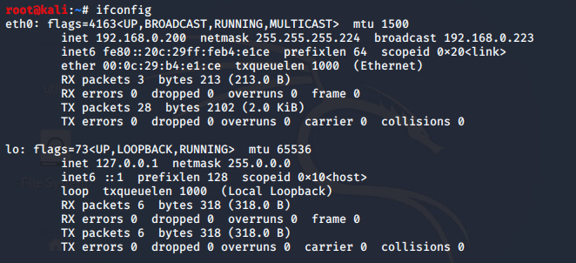Figure 1 – An image of the ifconfig command results

The following information was found out from the kali machine:

1. The IP address is 192.168.0.200
2. The netmask is 255.255.255.224
3. The broadcast address is 192.168.0.223

To be able to run the correct nmap scans it was important for the tester to use the shorthand for the netmask, which is .224,the netmask is /27 as it makes use of 27 out of the 32 available bits of an IP address when it is written in binary.

At this point in the test the address of Router 1 was not known to the tester, to be able to detect all the other devices that the kali machine was linked to (perform a host scan) the tester ran a command nmap –sn 192.168.0.200/27, the –sn flag is what instructs nmap to not do a port scan after the hosts have been discovered , and results in the only output being available hosts that responded to the scan. The results of the scan are shown below in Figure 2.

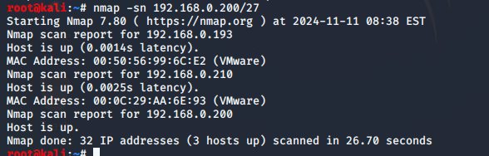Figure 2 – Results of Nmap scan

In the above image we can see that the Kali machine is connected to 2 others, 192.168.0.193, 192.168.0.210 where it can be assumed that one of them is a router and the other one is a device likely a PC.

Devices that are on a single subnet need to have IP addresses that stay within a certain range which is known as the Host ID range which can be found in the subnetting table in section 2.3, the subnet that the Kali machine is on remains within that range , which confirms that the subnetting arrangement is accurate.

From this we know that the Network ID for this subnet is 192.168.0.192/27 and as a result a nmap scan can be used for this address which would give us the results of the entire subnet and can be used to gain further information. This will scan the ports, the –sV will flag open ports to determine service/version info while the –oN flag writes the output to a text file, ports are specified with the –p, see image below for results.

Two new hosts were found doing this scan, one is a router at 192.168.0.193 and the second was a Linux PC at 192.168.0.210.

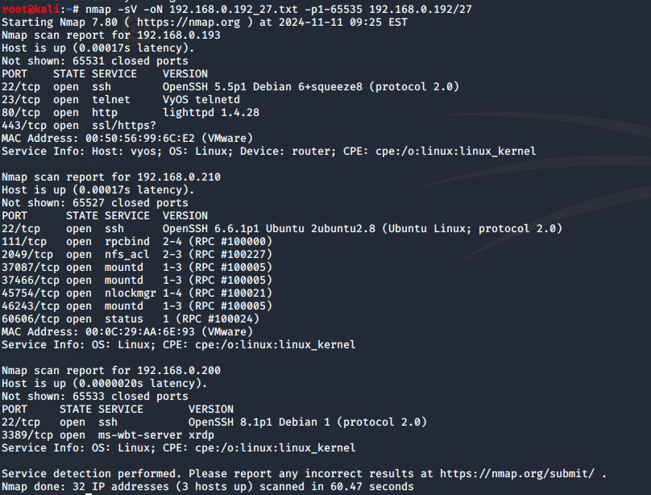Figure 3 – Image of Nmap results

## Router 1 – 192.168.0.193/27

As seen in the previous nmap scan, a telnet session is open on port 23 of the device which has the IP 192.168.0.193, when connecting to this using telnet 192.168.0193 the user is prompted to input credentials for VyOS, which is an “open-source network operating system that provides routing,firewall and VPN functionality” (Anantapatnaikuni, n.d.). Doing a google search for default credentials, the tester was able to find the username and password combination “vyos/vyos” (VyOS, n.d.)which were tried in the session, and they allowed for a successful login attempt as shown in the Figure 4 below.

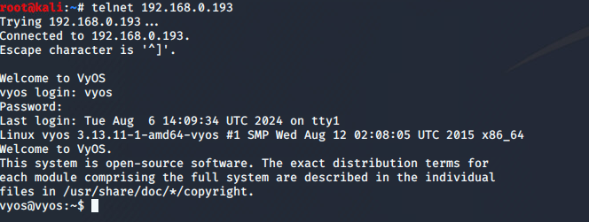Figure 4 – Image of successful telnet into VyOS on IP 192.168.0.193

From here, the interface and routing information can be displayed by using the show interfaces and show ip routes command to gather more information about adjacent subnet and devices. As shown in Figure 5 and Figure 5.1 below.

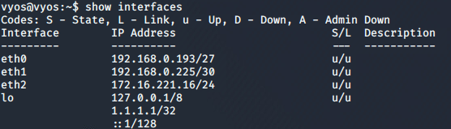 Figure 5 – Showing the interfaces

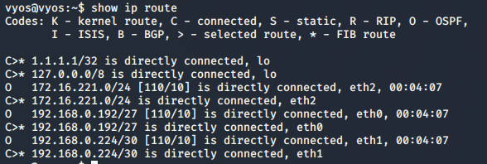Figure 5.1 – Showing the IP Route

By doing these commands the tester was able to discover three devices connected directly to the router on the eth1, 2 and 3 (as well as the local host interfaces) respectively.

The purpose of each of these connected devices are :

Eth1 : a second router directly connected to this one

Eth2 : a web server, determined by a nmap scan which was conducted against the IP address returned by the show ip route command , which showed the ports open on the device which are HTTP and HTTPS as shown in Figure 6 and Figure 6.1 below.

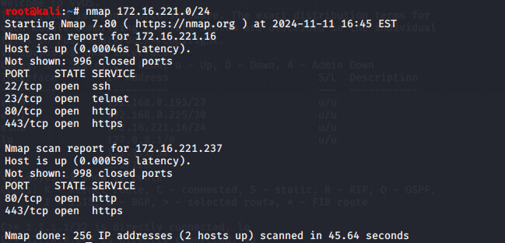Figure 6 – Nmap scan of the eth2 IP

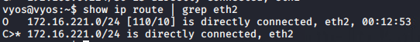 Figure 6.1 – Image to show the IP for eth2

And Eth3 : A switch that is directly connected device that routes a significant amount of other traffic through it , the devices that are connected to this switch are on the same subnet also.

### Web Server 1 – 172.16.221.237/24

Having previously discovered the web server’s existence on the network , the tester decided to run a further nmap scan on the web server address which returned a further address , 172.16.221.237. The tester made the decision to navigate to this address using a web browser which was Firefox. This resulted in the image of the webpage below in Figure 7.

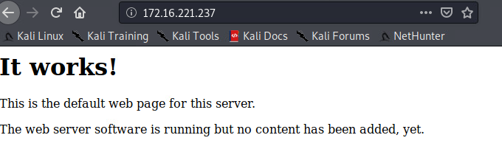Figure 7 – webpage on the web server

By discovering a webpage running on the server confirmed , the tester then ran 2 further tools on this address , a dirb scan which enumerates directories and pages that are present on the page and a Nikto scan which discovers any possible vulnerabilities that are present on the server.

The output for the dirb scan , the beginning can be seen below in Figure 11 and the rest in Appendix 2 – Dirb Outputs.

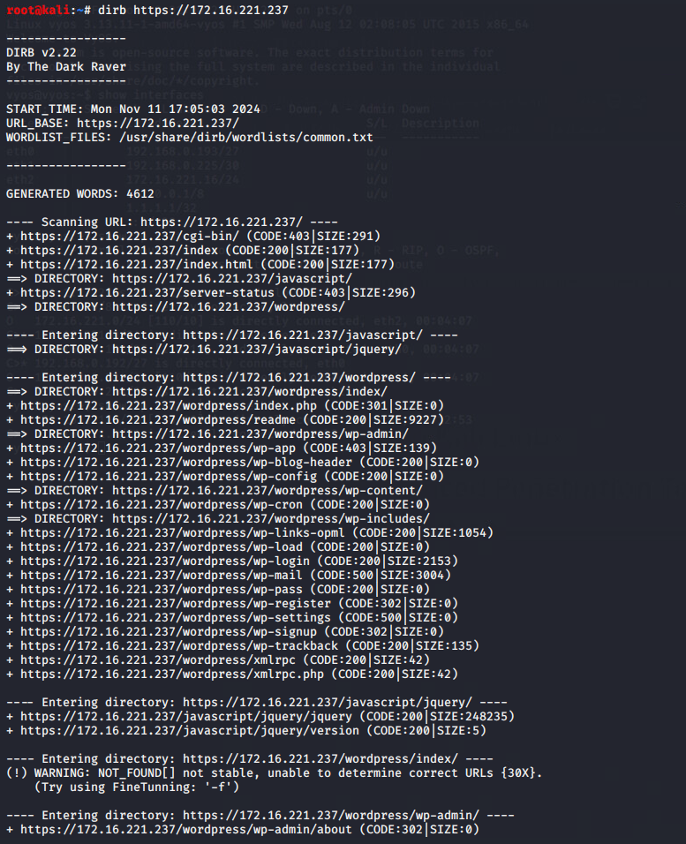

Figure 11 – The beginning of the Dirb Scan

The Dirb scan showed that amongst some miscellaneous things , that the site is being run on WordPress , which can be exploited by a tool called WPScan , which will be done later in this test.

The Nikto scan , which beyond displaying operating system , server software , showed no serious vulnerabilities , there were some issues however with unpatched software ( an outdated version of Apache) and unset headers are also present. The Nikto scan can be seen in Figure 12 below.

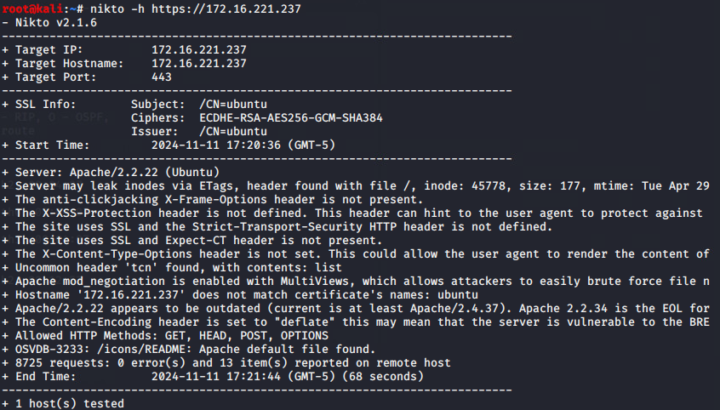Figure 12 – Image of Nikto Scan on IP 172.16.221.237

Using the information from the Dirb scan , the tester navigated to the /wordpress/directory which revealed additional content , which can lead to the main page of the site which can be seen in Figure 13 below.

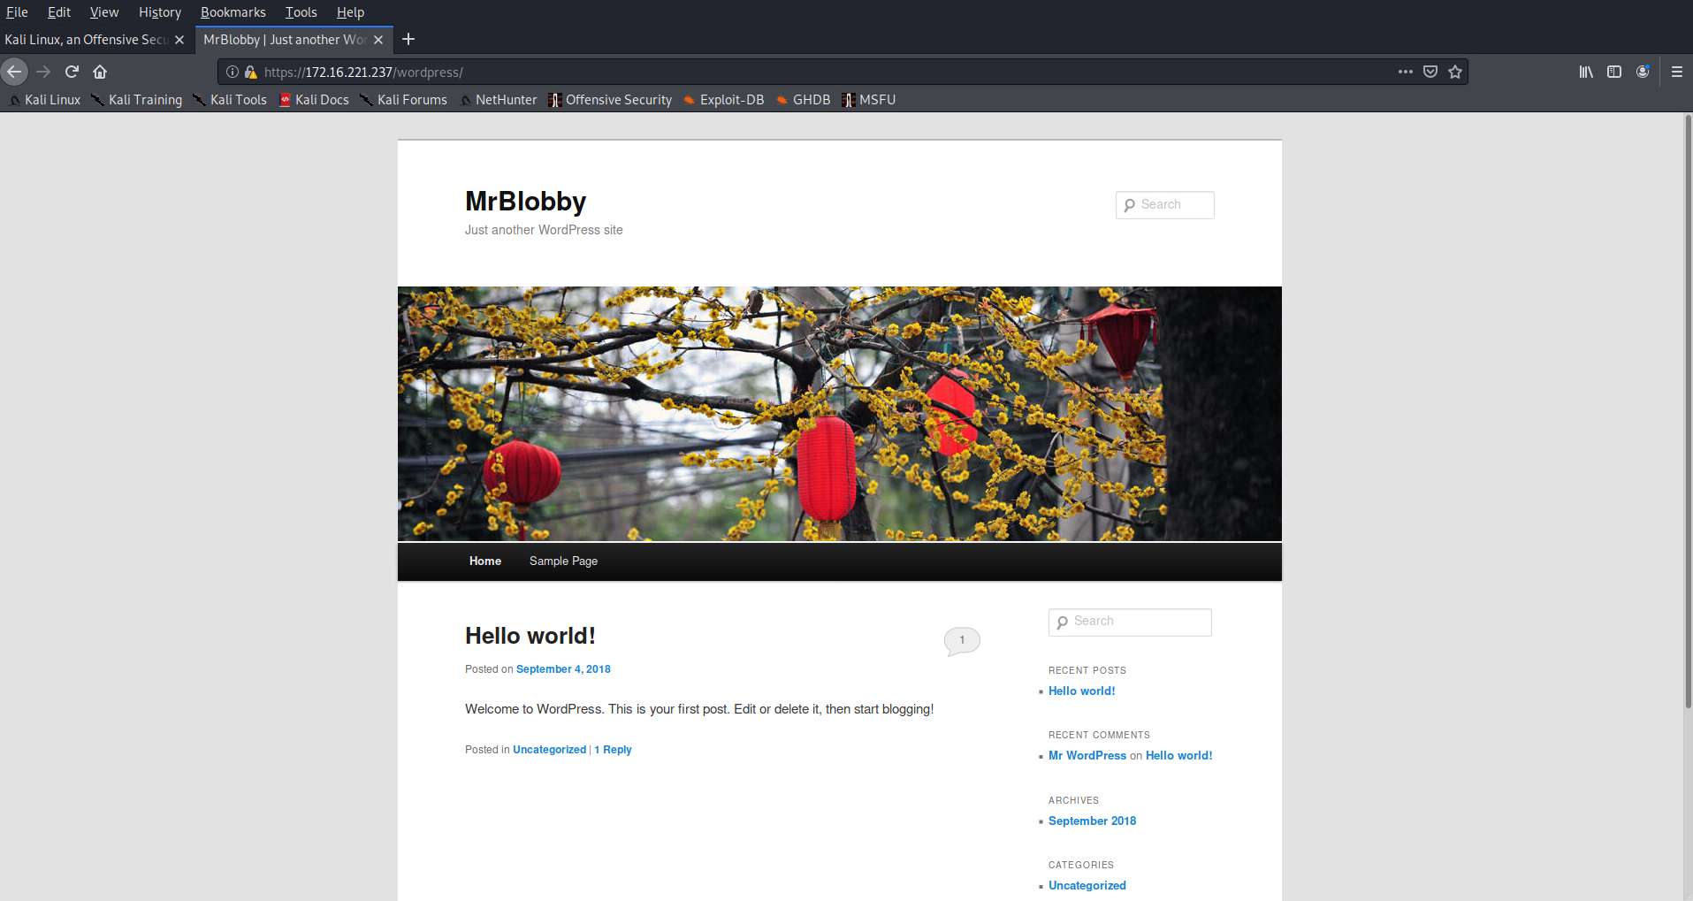

Figure 13 – Image of the 172.16.221.237/wordpress/

Now with the knowledge that the web server is running an instance of WordPress , the tool WPScan was used with the -url option set to the url of the wordpress main page , the -P(password) option set to default wordlist for john , the -U (username) option set to admin and -wp-content-dir flag set. This allows the tester to enumerate credentials for the admin account , which is the name for the default admin account in WordPress. The WPScan was successful and showed the tester the password “zxc123” , which was tested successfully against the admin page. Which is shown in the Figure 14 – Figure 14.3

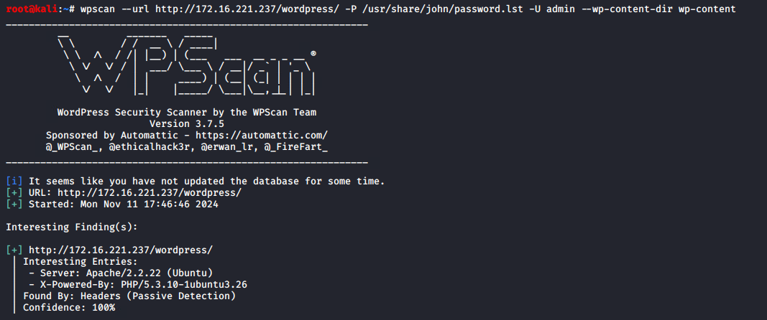 Figure 14 – Image of the WPScan beginning

 Figure 14.1 – The WPScan finding the admin password for the wordpress

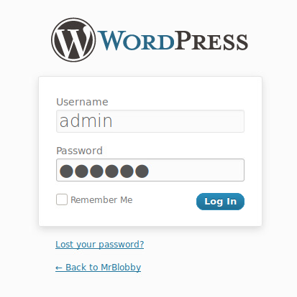 Figure 14.2 – the wordpress admin page with the credentials inputted

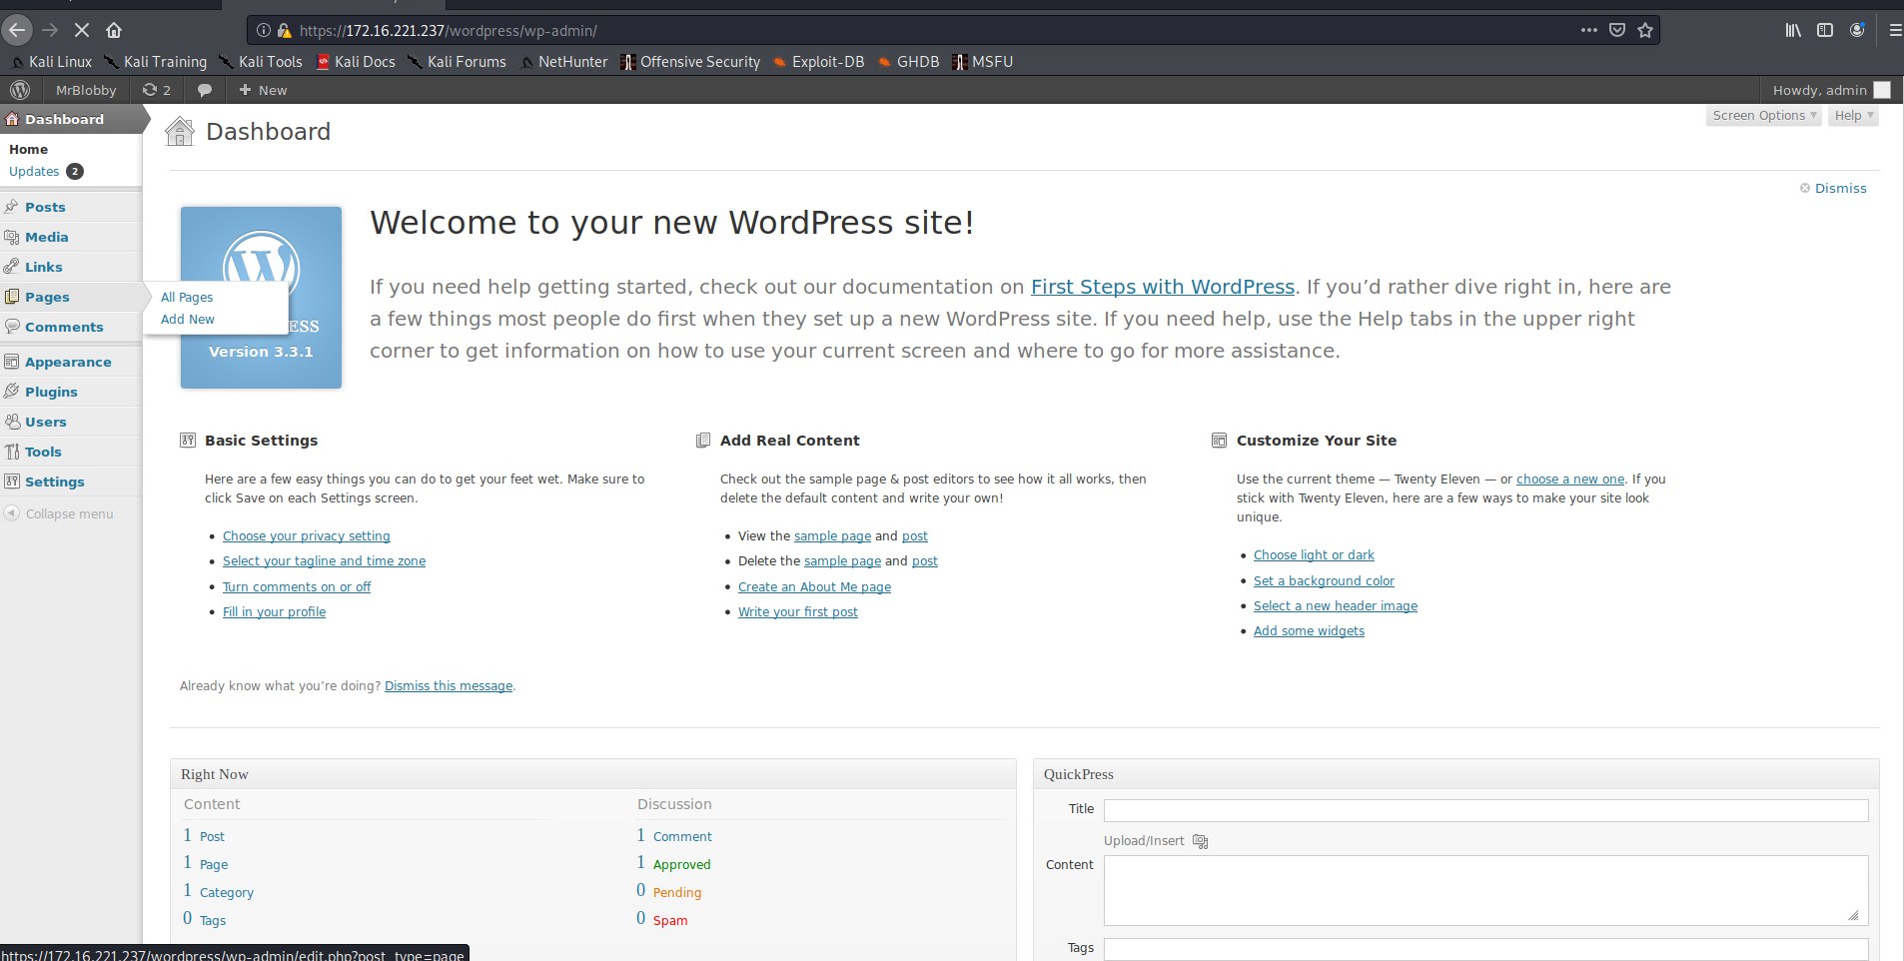Figure 14.3 – Wordpress signed in with admin credentials

Something the tester discovered when looking at the dashboard is that the version of WordPress that is being is very heavily outdated , this web page is using WordPress 3.3.1 where the most up to date version is 6.5 (at the time of writing) as shown below in Figure 15.

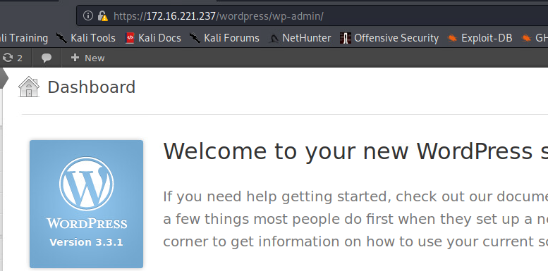

Figure 15 – The WordPress Version using 3.3.1

### PC 1 – 192.168.0.210/27

As was shown in the nmap scan earlier of the subnet , a PC is connected to router 1 which is located on the 192.168.0.210 and this device has 3 services running on it , NFS (port 2049) , rpcbind(port 111) and ssh(port 22).

The NFS, which stands for Network File System is a distributed file system protocol that allows the tester to create a mount on the Kali machine and then copy the files stored on that machine to theirs.

The tester created a tmp directory on their machine to store the contents of 210’s /etc directory , this will be explained below. In Figure 16-16.1 below is the process the tester used to mount the directory locally and the contents of the /etc directory. Which also contains system configuration files.

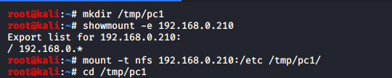 Figure 16 – Creating the tmp directory and mounting the nfs for 192.168.0.210

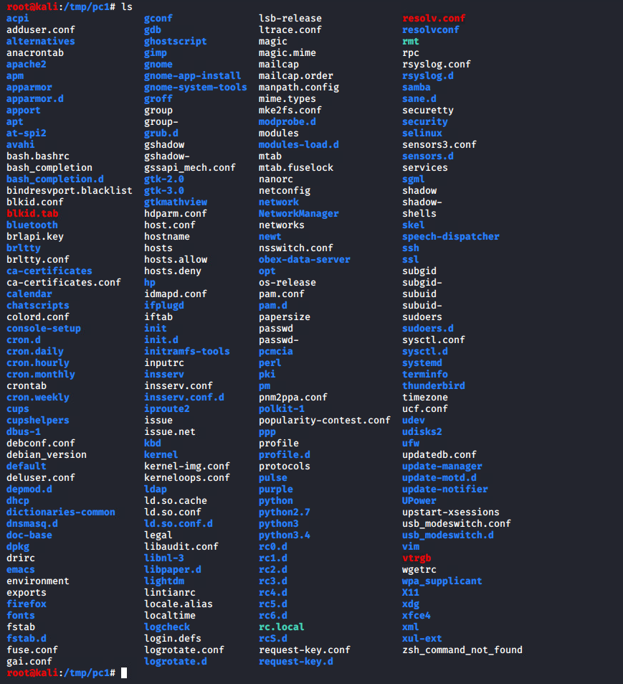 Figure 16.1 – Viewing all the files on the nfs for 192.168.0.210

The tester moved onto the shadow file , which is where user account information is stored . This includes usernames ,encrypted passwords , minimum and maximum allowed days between password changes and the date of the last password change.

In Figure 17 -17.1 shown below , there are many user accounts present on this device , however most of them are locked accounts intended for use by services. There is only one account designed for direct access by an end user and that is the xadmin account as seen by the presence of a password hash. The tester copied the shadow file to a permanent directory on their machine to later crack the account.

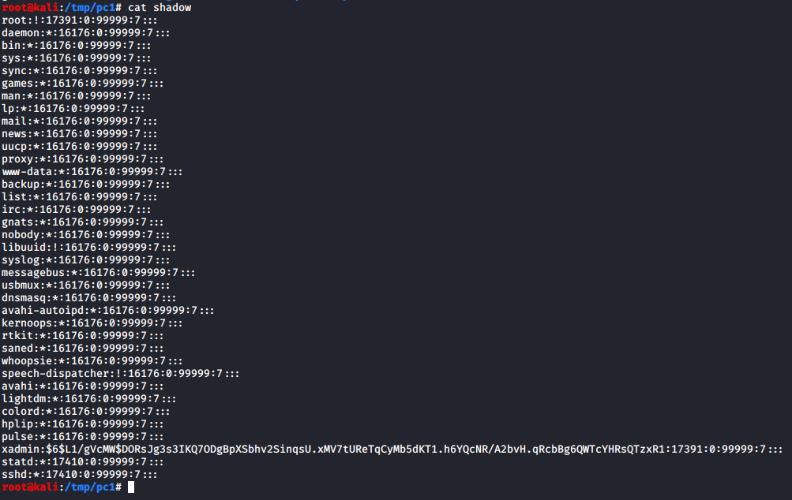Figure 17 – The information from the shadow file

 Figure 17.1 – Copying the file to the testers machine

One this was done the tester used John the Ripper hash cracking tool, which is a part of Kali , once this was complete as shown in Figure 18 below. The password for the xadmin account was revealed to be “plums” , which allowed the tester to establish a SSH connection to the device.

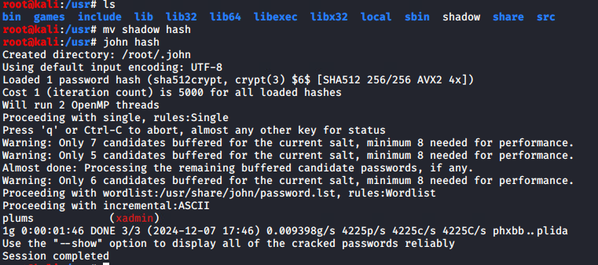Figure 18 – John the Ripper cracking the password

Being able to SSH to the device allowed the tester to determine the connections the PC had to any other devices; it was found that the PC was only connected to one other device , a router through the Eth0 interface.

The xadmin account was also determined to be a superuser account as the tester could alter the device as they see fit through this account. This will be covered in the security weaknesses section in more depth.

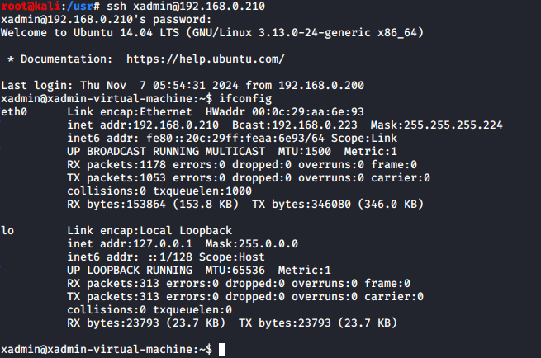Figure 19 – ssh connection successful with ifconfig check

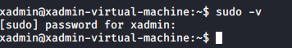 Figure 19.1 – sudo check

## Router 2 – 192.168.0.226

When the command show ip route was done , it was deduced that there is a second router on the network which is located at the address 192.168.0.226. This is connected via the eth1 interface which is known due to the amount of traffic that is routed via this address in the earlier scans. When the interfaces command was conducted on the previous router , it was shown that the netmask is /30, the tester also knew that there are 4 addresses in this subnet of which 2 were usable host addresses. As shown in the scan below in Figure 20 the 2 usable host addresses 226 and the 225 which means that the network address was the 224 and the broadcast address was the 227 , in the nmap scan is also shows the open ports on this subnet.

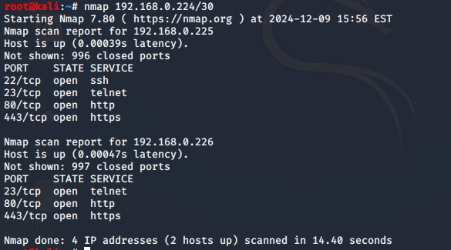 Figure 20 – nmap scan against router 2’s network address

In the above nmap scan there is a telnet session available on both devices , as with Router 1. As the tester has previously done , they attempted to connect to the .226 address using the VyOS default credentials which was successful again as shown below in Figure 21.

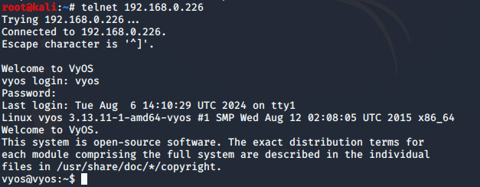 Figure 21 – telnet session on 192.168.0.226

By using the show interfaces and the show ip route commands it revealed 192.168.0.228/30, and the 192.168.0.32/27 subnets connected to Router 2 as shown below in Figure 21.1

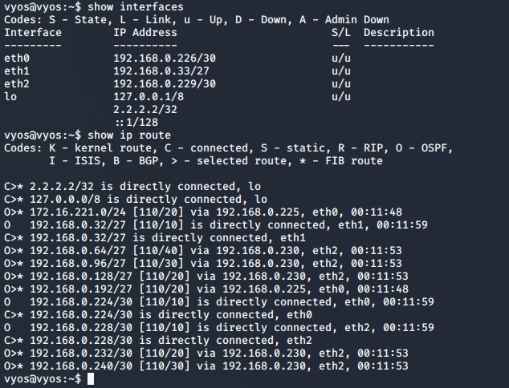Figure 21.1 – Interface and routing info for Router 2

It can be deduced that the devices connected to this router are as follows :

* Eth1 : PC 2 with the address .34/27
* Eth2 : Router 3 , as deduced by the number of devices connected to it.
* Eth3 : Router 1

### PC 2 – 192.168.0.34/27

A nmap scan was run on the target’s subnet network address 192.168.0.33/27 and it revealed that a ssh session was available on this device as shown in Figure 22 below. The tester made use of the previously acquired xadmin credentials (xadmin/plums) to access this device. This was successful and upon accessing the device , the tester ran an ifconfig command to see what devices were connected to the network as shown in Figure 22.1 below.

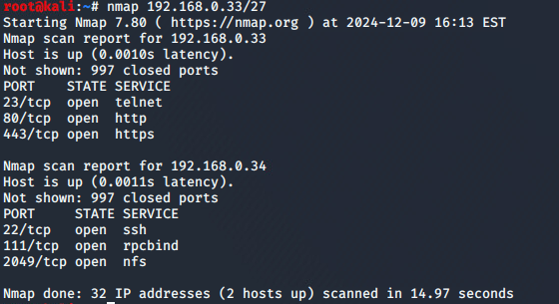 Figure 22 – nmap scan of the subnet

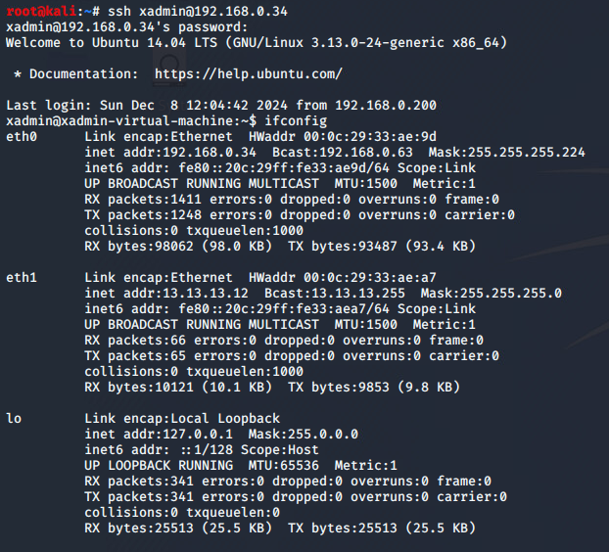 Figure 22.1 – successful ssh connection and ifconfig command output

The results of the ifconfig command have shown the presence of a second device connected via the first PC’s eth1 interface which is located at the address 13.13.13.10 with a netmask, it can be deduced that the network address of this subnet is 13.13.13.0.

The tester then ran a history command , which displays the history of the device to determine if a ssh connections have been established to a device at 13.13.13.13. It was discovered by the tester that at command 15 was an attempt to ssh into the device in question using the xadmin account , which confirms that the device at this address is indeed a PC. This can be seen in Figure 23 below.

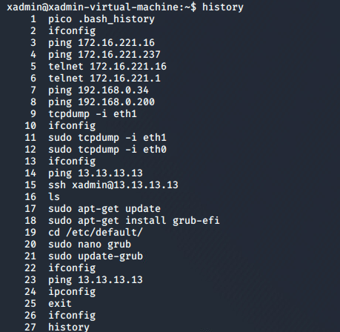 Figure 23 – info from the history command

For the tester to be able to gain permanent access to this third pc , it was necessary to create a pivot point on PC 2 . To be able to achieve this , editing the sshd_config file on the system to be able to permit tunneling and then open a tunnel interface on the remote devices as shown in Figure 24 below.

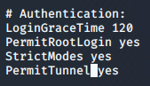 Figure 24 – Editing the sshd_config file , to include the Permit Tunnel and changing the PermitRootLogin to yes

To be able to do tunneling root access is needed , so passwd -S was run for the root user after gaining su permissions on PC2 as shown in the below Figure 25 which also shows opening the tunnel and restarting the ssh service.

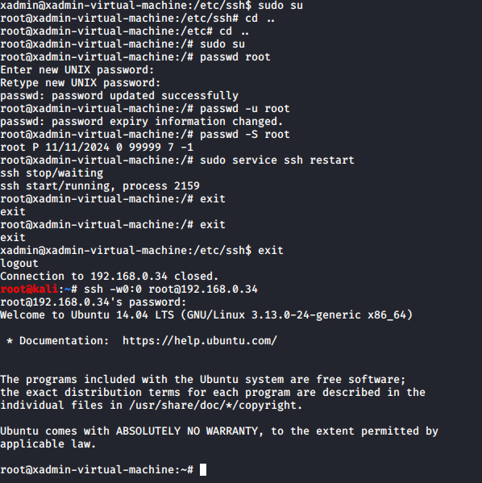Figure 25 – Changing to root and unlocking root password , creating a tun0

The next thing is to add the tun0 in the Kali machine and in the PC2 at 192.168.0.34 and then set the tun0 up. In Figure 25.1-25.4 is the set up on the [root@192.168.0.34](mailto:root@192.168.0.34) PC2. In Figure 25.1 once signed in using ssh -w0:0 [root@192.168.0.34](mailto:root@192.168.0.34) the command ip addr was used to check that the tun0 was created and then can be assigned an IP.

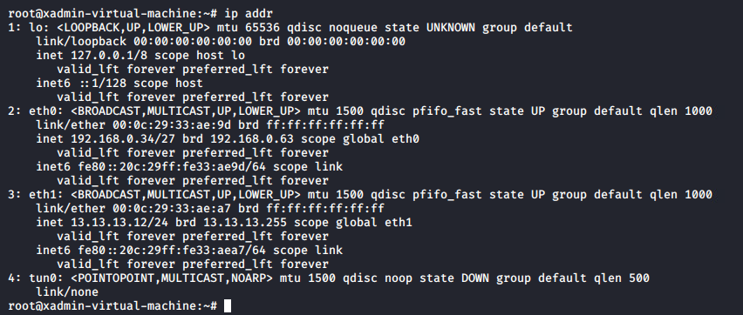Figure 25.1 – the tun0 is created

In Figure 25.2 below an IP was assigned on PC2 and its state was changed from DOWN to UP and then confirmed by using the command ip addr.

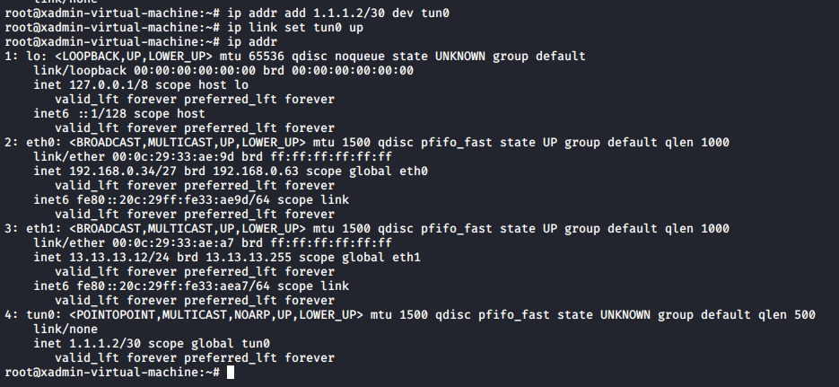Figure 25.2 – setting up tunnel on PC2

Now that the tunnel is set up on PC2 , the kali machine needs to be able to forward traffic. This was done by routing through IPv4. To be able to do this the file “forwarding” within the directory “/proc/sys/net/ipv4/conf/all/” needs to be changed so that the contents will change from 0 to 1. As can be seen in Figure 25.3.

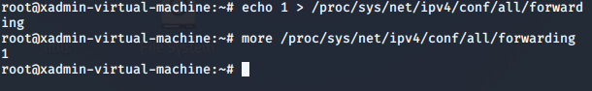Figure 25.3 – changing the contents of forwarding file from 0 to 1

By using the command in Figure 25.4 this allows devices in the 1.1.1.0/30 subnet to access external networks via the eth1 interface by masquerading the source IP address allowing the connectivity through the SSH tunnel.

Figure 25.4 – setting up nat

Once this was set up the tester did something similar on the Kali machine as shown in Figure 26-26.1 below.

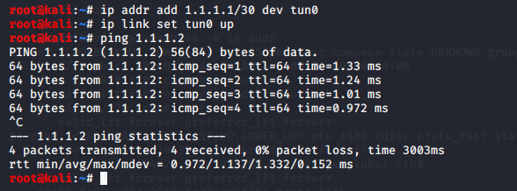Figure 26 – setting up kali tunnel and ping test PC2

Once the Kali tunnel was set up , the tester then added the route to PC3 and then tested it by pinging the 13.13.13.13 which was successful.

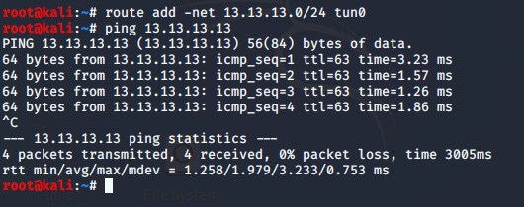 Figure 26.1 – Adding route to PC3 and pinging PC3

### PC 3 – 13.13.13.13/24

Now that PC3 the 13.13.13.0/24 subnet is accessible from Kali , a nmap scan was run on it which confirmed the existence of a PC using SSH as shown in Figure 27 below.

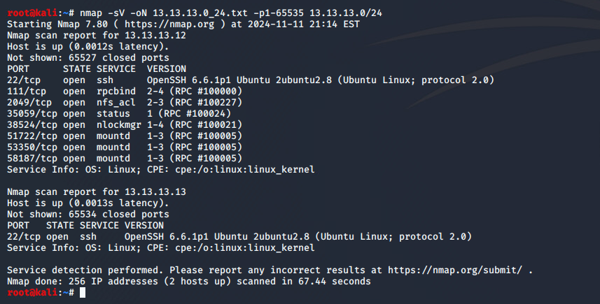Figure 27 – nmap on the 13.13.13.0/24 subnet

An attempt to connect to this PC using SSH with the previous password was unsuccessful. The tester has decided to use Metasploit’s Framework for the ssh_login brute force module as shown below in Figure 28-28.1

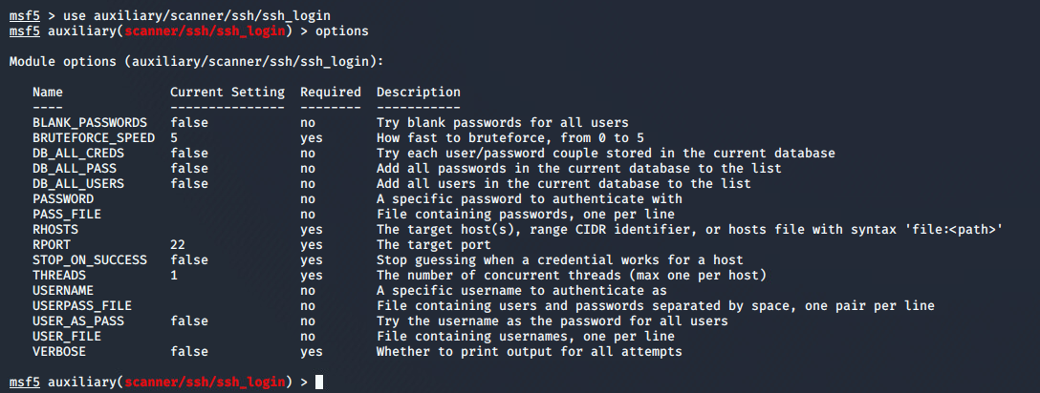Figure 28 – checking options on the ssh_login module

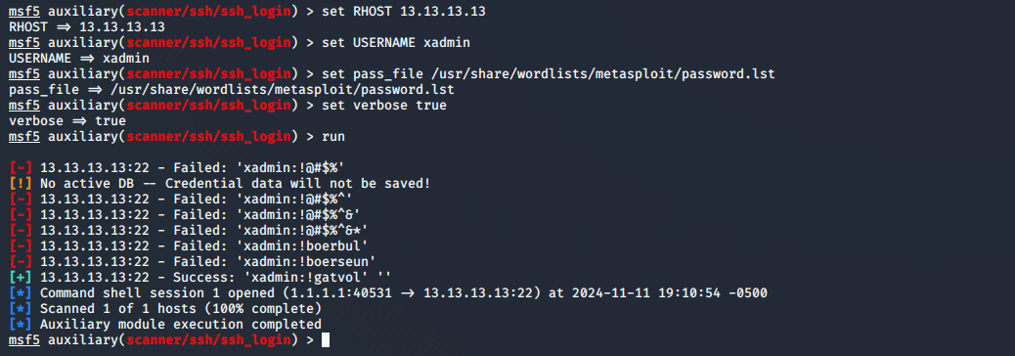Figure 28.1 – getting password for PC3 13.13.13.13

Using this process has revealed the password for this device is “!gatvol”, which when the tester tried, it allowed for a successful login as shown below in Figure 28.3.

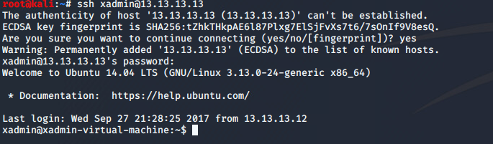Figure 28.3 – Successful login

The ifconfig command was run and it showed that this device is not connected to any other device apart from PC2 , which confirms that this is the only device on this subnet.

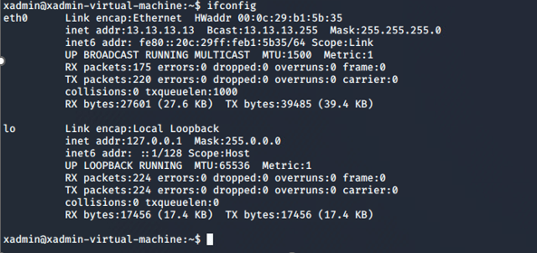Figure 28.4 – ifconfig command on 13.13.13.13

## Router 3 – 192.168.0.230

As shown in Figure 21.1 , there is a telnet service open on Router 2 which is seen by using the commands for showing interfaces and ip routes , there is a significant portion of traffic being routed through the IP 192.168.0.230 on the Eth2 interface. With this information it can be deduced that this device is most likely a router. The IP that is associated with Eth2 interface is 192.168.0.229/30 which the tester knows from Router 2 and Figure 20 which shows 2 usable hosts. The tester then ran 2 nmap scans against the interface which revealed the following information below in Figure 26-26.1.

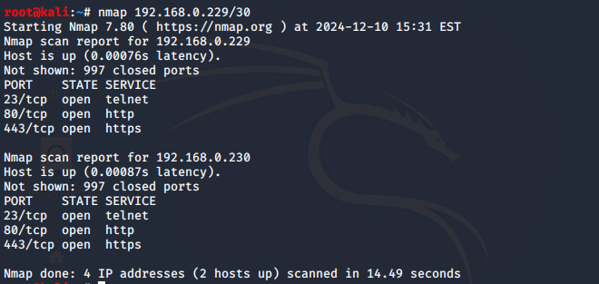Figure 26 – Nmap scan of 192.168.0.229/30

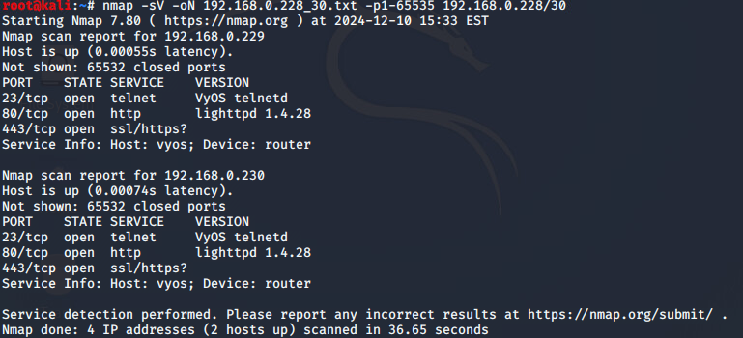Figure 26.1 – Additional Nmap scan of 192.168.0.228/30

It was shown that Router 3 is also running Telnet and using the same default credentials for the VyOS platforms. Once access was gained , information about any additional hosts or subnets was gathered as shown in Figure 27- 27.2 below. This revealed 2 previously unidentified directly connected subnets – 192.168.0.128/27 and 192.168.0.232/30.

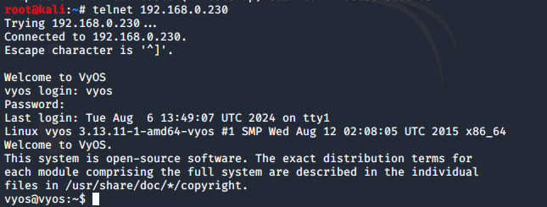Figure 27 – signing into telnet on Router 3

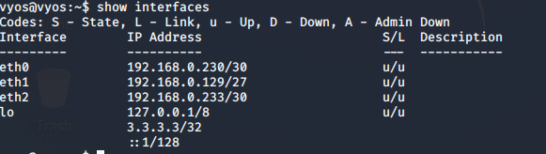 Figure 27.1 – show interfaces on Router 3

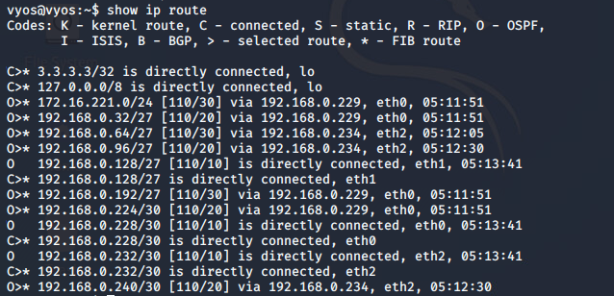Figure 27.2 – show ip route on Router 3

### PC 4 – 192.168.0.130/27

When doing a nmap on the 192.168.0.128/27 , the IP 192.168.0.130 was located . This PC was using SSH and NFS, as shown in Figure 28 but it was not possible to connect via SSH like previously as the SSH key for Kali was not authorized.

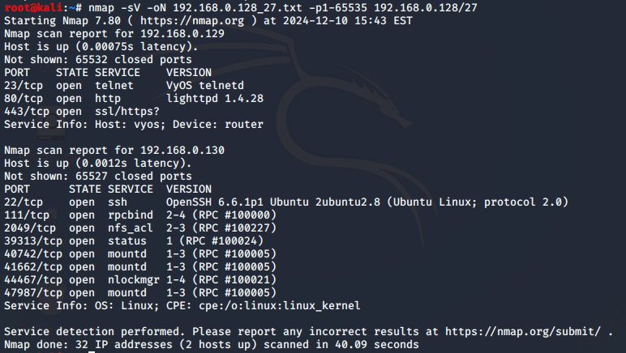Figure 28 – nmap scan on 192.168.0.128/27

With the presence of NFS , this allowed the tester to repeat the process from PC1 , where a temporary mount is created on the testers machine and the contents of any directory which in this case is the home directory are dumped for local analysis. This is shown in Figure 29 below.

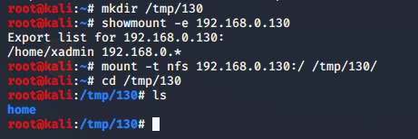 Figure 29 – mounting the home directory to a temporary

From the authorized_keys file that is found at /tmp/130/home/xadmin/.ssh/, it is shown that this machine has been accessed previously by another machine at some point and through the process of elimination it was determined that it was PC 2.

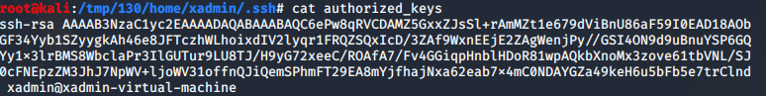Figure 29.1 – authorized_keys file on PC4 showing a previous machine has accessed it

The tester was then able to connect to PC4 through PC2 and then ran the ifconfig command to see if any other devices are connected to it. The output is shown below in Figure 29.2 and confirms that it was not connected to any other device apart from the router.

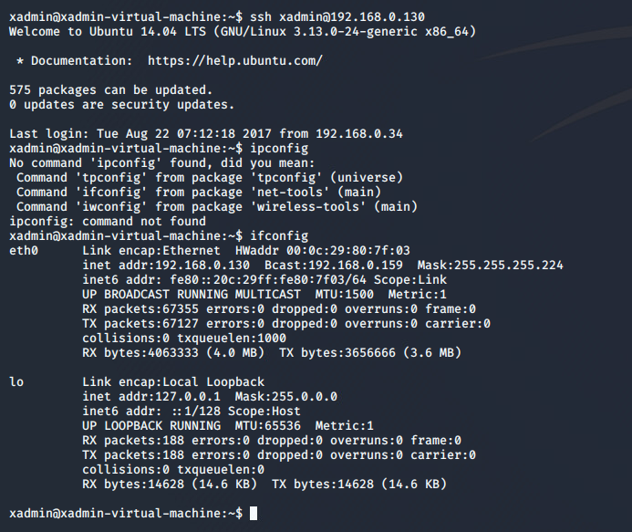Figure 29.2 – Interface information on PC4

## Firewall - 192.168.0.240/30

When the tester scanned the 192.168.0.232 subnet which Router 3 is directly connected to , the scan returned no new results. With these results it is suspected that a firewall could be present. This was confirmed by doing further scans on the subnets 192.168.0.64/27 and 192.168.0.96/27 which showed in Router 3’s routing table connected via 192.168.0.234 which belongs to the 192.168.0.232/30 subnet. The two scans have shown nothing new or any new discoveries, a scan of 192.168.0.24/30 which is also shown to be connected to Router 3 via the 192.168.0.234 did indicate another webserver running SSH as shown in Figure 30 below.

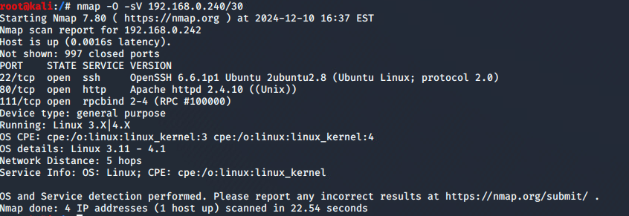Figure 30 – nmap scan on the firewall

The tester visited the IP address that is associated with the device , and it was confirmed to be a web server as shown in Figure 31 below which is the landing page for .240 website.

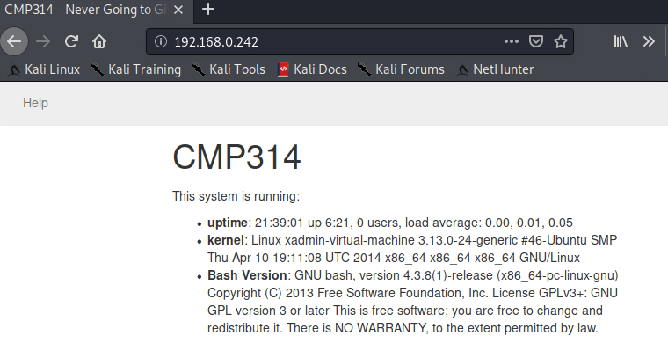Figure 31 – that landing page for the website

There was a Nikto scan of the web server which reveals several possible vulnerabilities , amongst them is that the server is vulnerable to the “shellshock” vulnerability, which is an issue with the bash shell on the target device allows for remote code execution as can be seen in Figure 31 below.

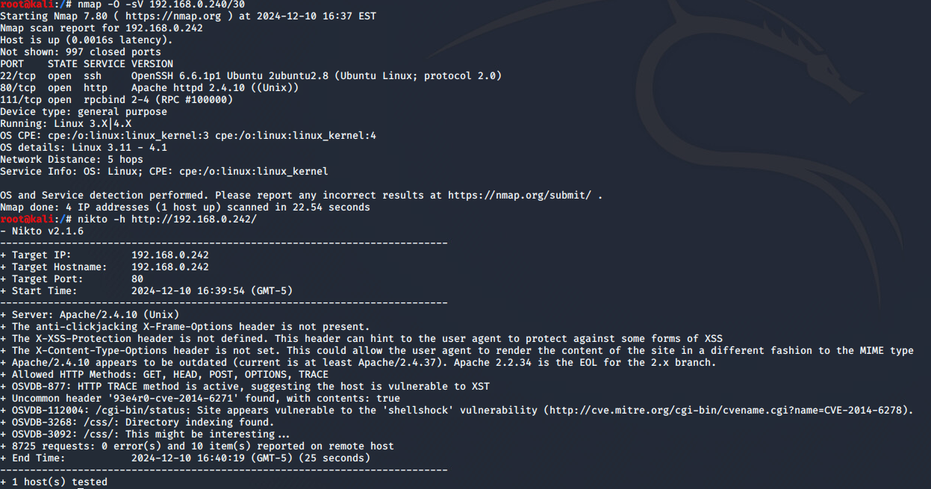Figure 31 – Nikto scan of web server 2

The tester used Metasploit to be able to exploit this vulnerability on the target’s device. The tester selected the “Apache mod_cgi Bash Environment Variable Code Injection (Shellshock)” module as the vulnerability to use due to it being an Apache server. As shown above in Figure 31 that the vulnerability is in the 192.168.0.242/cgi-bin/status , the RHOST’s option was set to the target’s IP and the targeturi option was set to the relevant directory which is the /cgi-bin/status. This allowed the tester to be able to open a meterpreter shell on the target device once it was run and the full output of this can be seen in Appendix 5 – Metasploit.

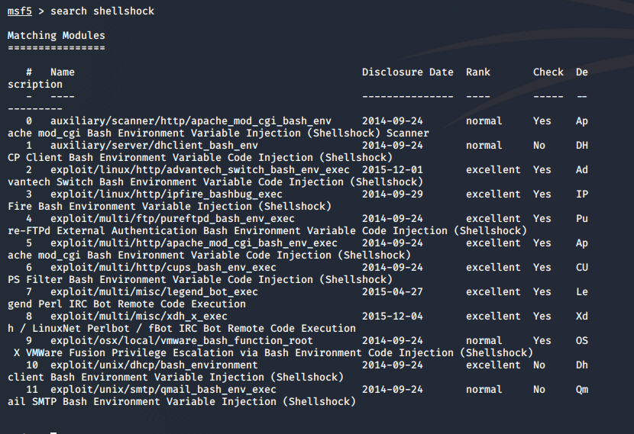

Figure 32 – Searching the vulnerability in Metasploit

Now that the tester has gained access to a meterpreter shell they have employed the use of port forwarding to gain access to the firewall on their local kali machine.

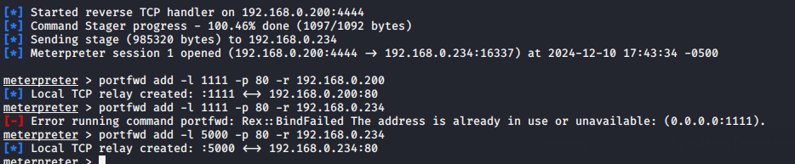Figure 33 – port forwarding

Once the port forwarding was done , the tester navigated to localhost:5000 and was able to access the pfsense login page for the firewall as shown in Figure 34 below.

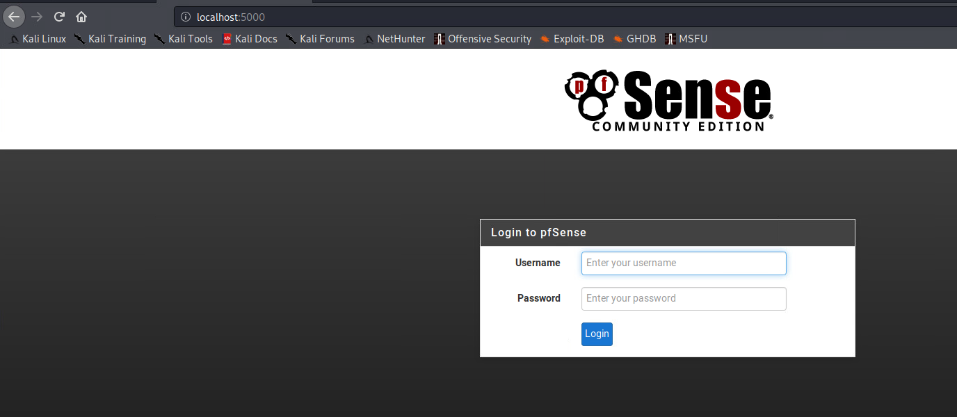Figure 34 – login page for the firewall

Once the tester was logged in , they could see the pfsense dashboard as shown below in Figure 34.1. Which also shows 3 devices that are connected directly through the firewall. These are as follows:

WAN: Router 3 – 192.168.0.234/30

LAN: A 4th Router – 192.168.0.98/27

DMZ: Web Server 2 – 192.168.0.241/30

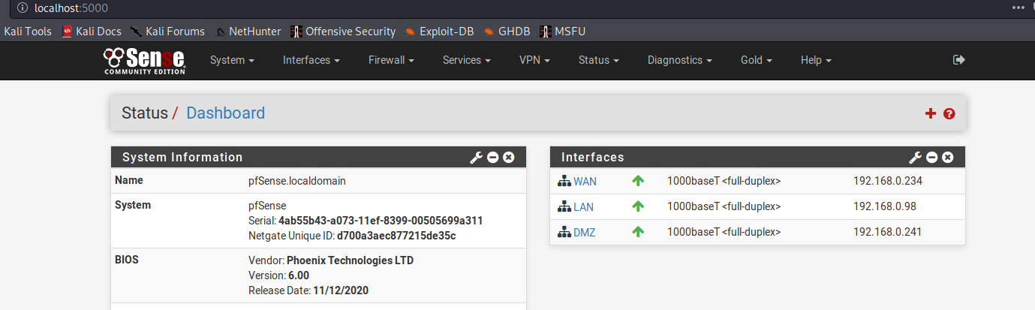Figure 34.1 – pfsense dashboard for the firewall

The tester had a look at the firewall rules in Figure 34.2. It is shown that any IPv4 traffic from any source is passed through to 192.168.0.242 (Web Server 2).

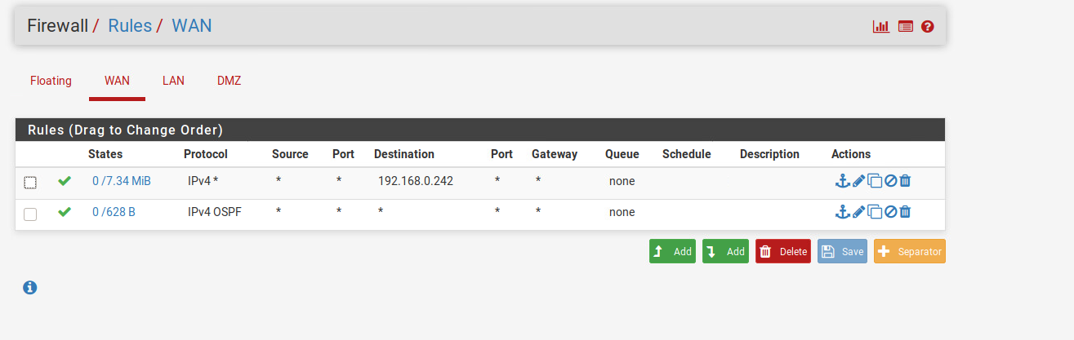Figure 34.2 – WAN Rules on the firewall

In the rules for the LAN as shown in Figure 34.3 , this allows for all traffic that originates from the local area network to pass, which means that any device within the LAN will have access to any other hosts within the LAN and the rest of the network.

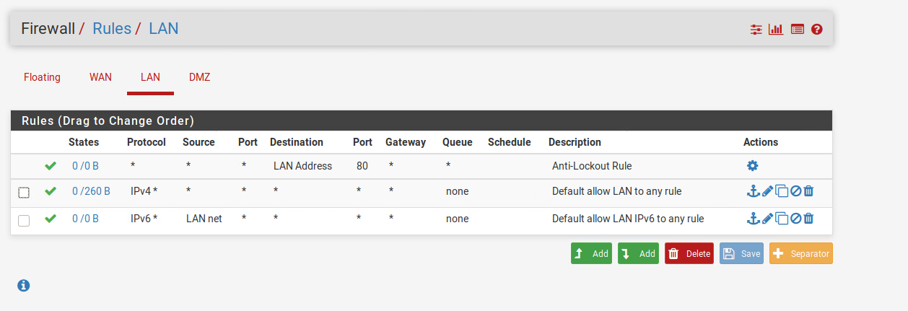Figure 34.3 – LAN rules for the firewall

In the last section the DMZ only had 2 out of the 8 rules enabled, which is that IPv4 traffic from any destination can only reach 192.168.0.66 which is PC5 which is why in section 3.5.1 it is the only host appearing in a scan of that subnet. For rule 2 it allows for traffic to reach any destination , however this rule is not in affect due to the rule’s prioritization from the top down and only the first rule that matches that packet type will be executed while the rest are skipped. Since they both apply for the same packet type the second rule will not be executed, this can be seen in Figure 34.4 below.

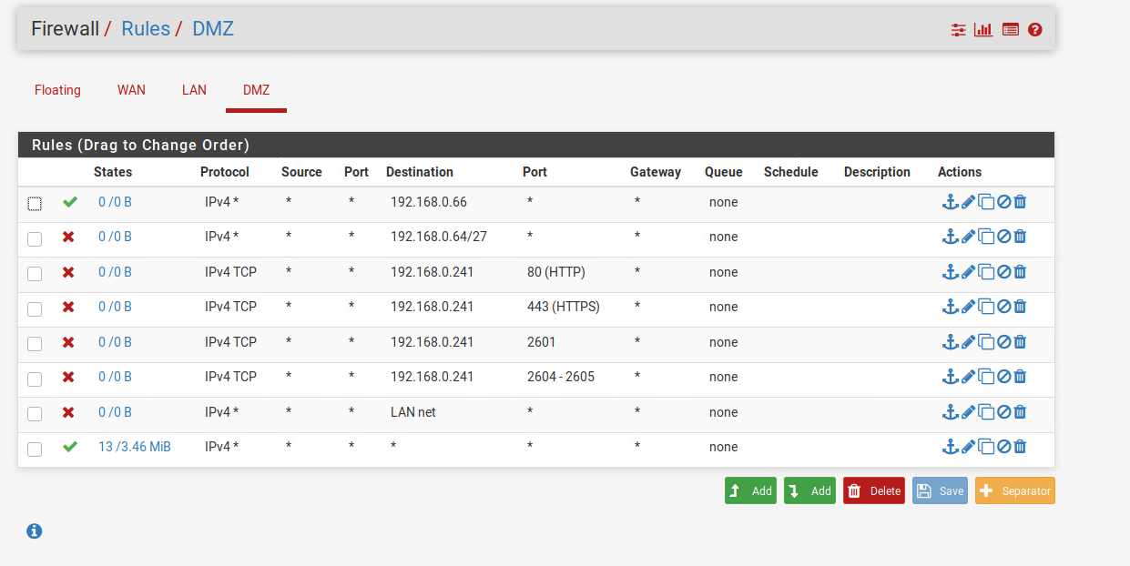Figure 34.4 – DMZ rules for the firewall

### Web Server – 192.168.0.242/30

Now that the firewall has been explored the tester has moved back to the meterpreter shell they received by using the shellshock exploit in the previous section. To be able to get a password to be able to SSH into the 192.168.0.242 web server 2. To be able to do this the tester downloaded the /etc/passwd and the /etc/shadow files to be able to use them later for password cracking as shown in Figure 35 below.

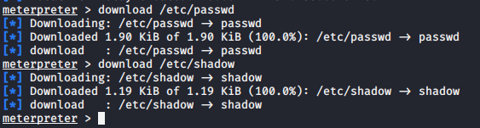 Figure 35- Downloading /etc/passwd and /etc/shadow files

On the Kali machine , the tester used john the ripper to crack the password as shown in Figure 35.1 below , there were 2 sets of login information found which is root/apple and xweb/pears.

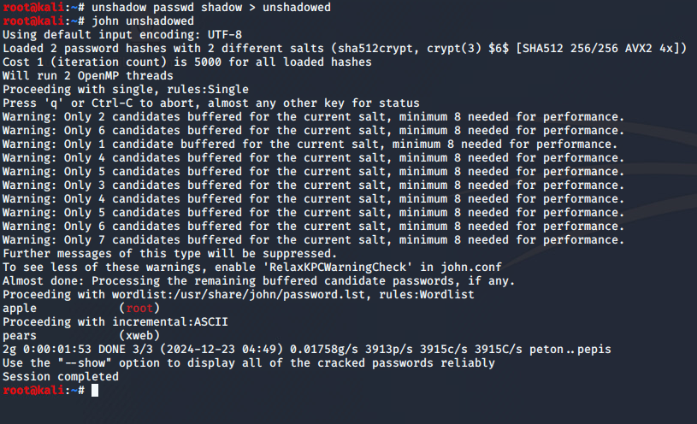Figure 35.1 – Using John, the Ripper to crack the password

Now that the password has been cracked , it is possible to try and SSH into the [root@192.168.0.242](mailto:root@192.168.0.242) again which as shown below in Figure 35.2 this was successful.

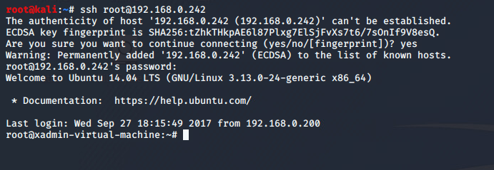Figure 35.2 – Successful SSH login attempt to 192.168.0.242

In Figure 35.3 , it was confirmed by using the ifconfig command that there are no new devices connected directly to the hosts.

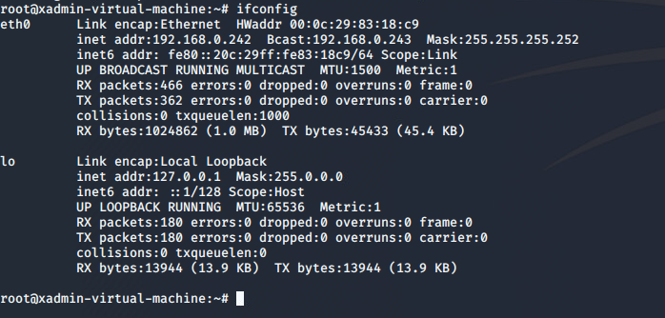Figure 35.3 – ifconfig command on 192.168.0.242

## Router 4 – 192.168.0.97/27

For Router 4 with the firewall restrictions in place which would not allow devices within the LAN to be seen by devices outside of it, unless these firewall rules were to be edited which the tester has done by adding in a rule for the WAN to be able to nmap the 192.168.0.98/27 subnet.

The tester has added a rule in the WAN rules to allow the TCP/UDP protocols as shown in Figure 36-36.1 below.

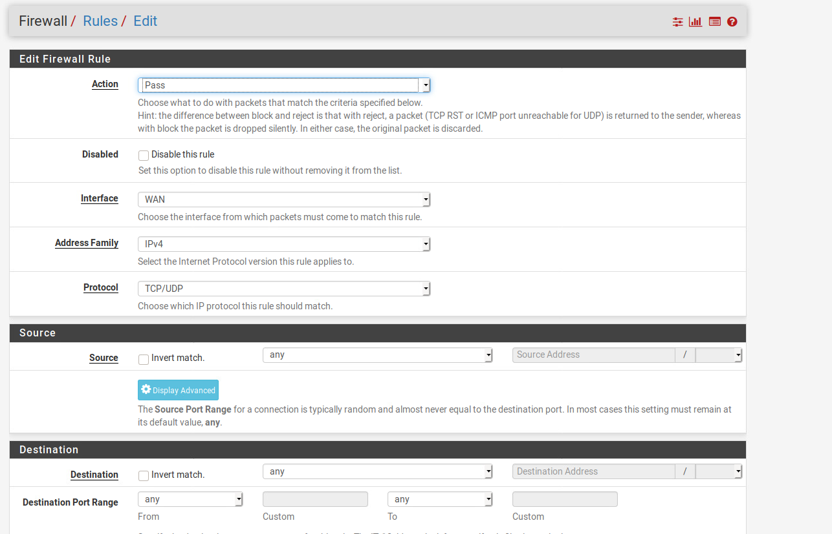Figure 36- Added rule to WAN

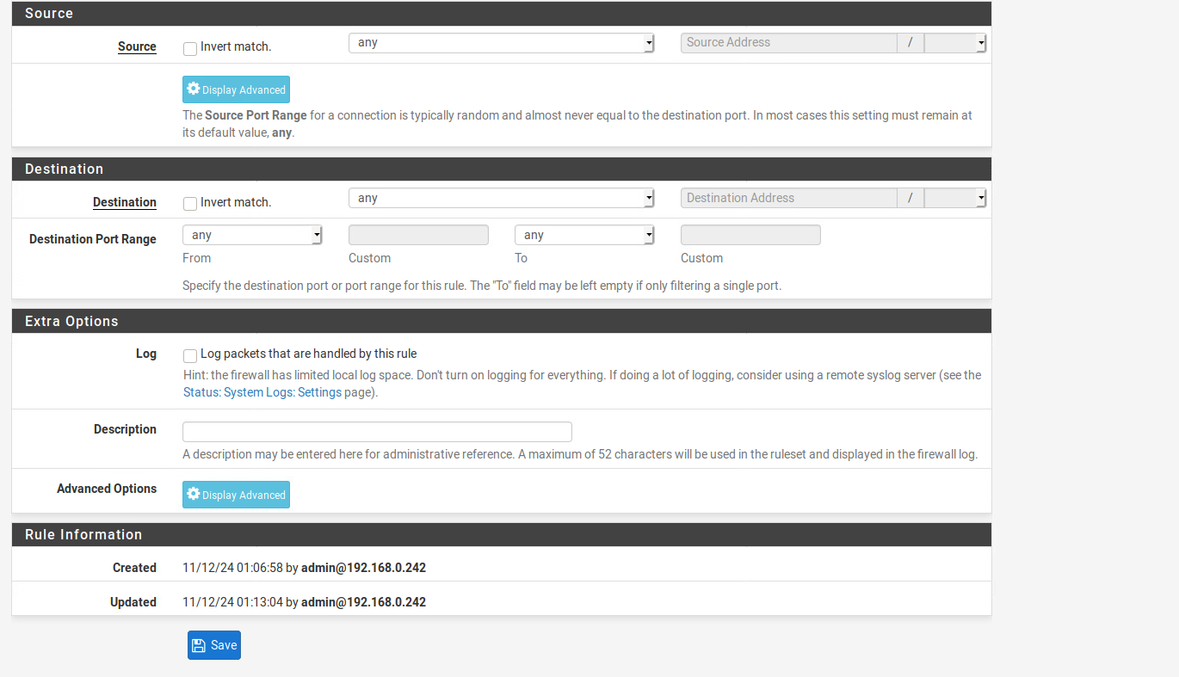Figure 36.1 – Continued rule for the WAN

With this rule now in place, it is possible to do a nmap scan on the 192.168.0.96/27 subnet which is shown below in Figure 37 which shows that the fourth router has an open telnet session.

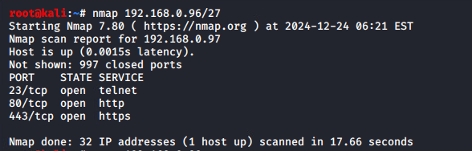Figure 37 – nmap on the 4th router

The tester was able to gain access to the telnet session , which was an VyOS like the previous routers which was successfully connected to by using the default credentials like before as shown in Figure 37 below.

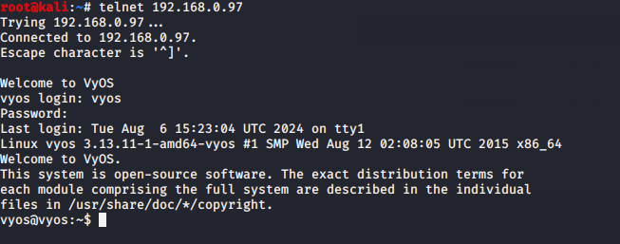Figure 37 – successful telnet connection to 4th router

Once connected it was possible to view the interfaces and the ip route which shows only 2 interfaces being used eth0 – 192.168.0.97/27 and eth1 – 192.168.0.65.27 as shown below in Figure 37.1.

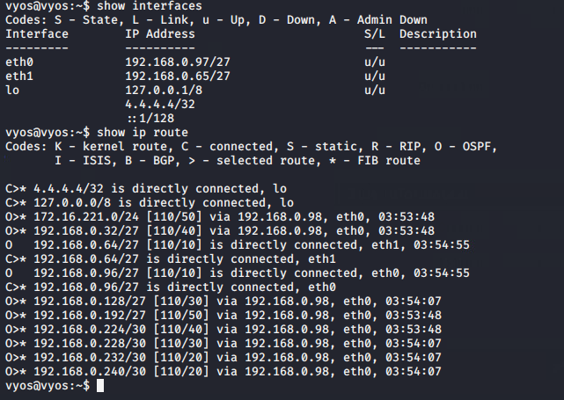Figure 37.1 – show interfaces and ip route on router 4

The purposes of the devices that are connected to these interfaces are as follows :

Eth0 – the firewall

Eth1 – the 5th pc directly connected to the router

### PC 5 – 192.168.0.66/27

Afte this host was found an nmap scan was conducted against the subnet the pc was hosted on. As shown below in Figure 38 this shows an open SSH session on the target , but when the tester attempted to SSH into the machine using the xadmin account there was an error as shown in Figure 38.1 which said, “Permission denied (publickey).”

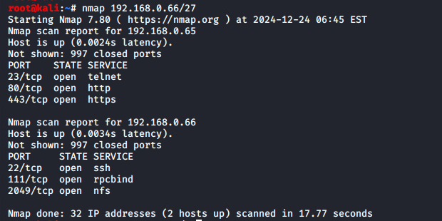

Figure 38 – nmap scan on pc5

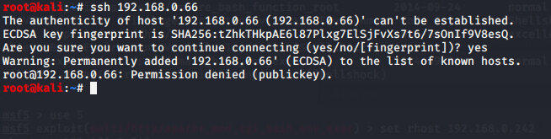Figure 38.1 – access denied for ssh session on pc5

The tester decided to create an NFS mount as was done in previous sections earlier (section 3.1.2 and section 3.3.1 ) and generate an RSA key to be able to access the SSH server themselves.

As shown below in Figure 39, the tester has mounted PC5 into a temporary folder.

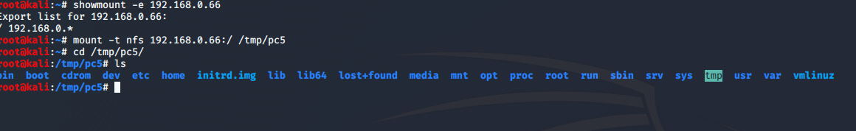Figure 39- creating the temporary mount for pc5

Once the mount has been created , the ssh-keygen -t rsa command was used , which will generate a public and private rsa2 key pair , the tester used “root” as their passphrase for the key to authenticate them. This can be seen in Figure 39.1 below .

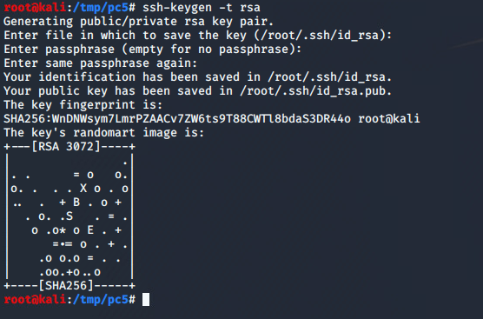 Figure 39.1 – generating the public/private rsa key pair

The NFS mount will dynamically change the content of the target’s device , due to this the tester was able to create a .ssh directory under the root user’s home directory and then copy the public key that was generated to a file called authorized_keys and then able to successfully SSH into the target machine. This can be seen below in Figure 39.2.

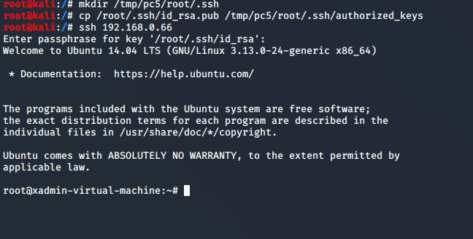Figure 39.2 – adding the rsa key to the file and then gaining successful access through the SSH

Now the tester has gained successful access to PC5 , the tester then ran the ifconfig command which showed the device wasn’t connected to any other devices except Router 4 which can be seen in Figure 39.3 below.

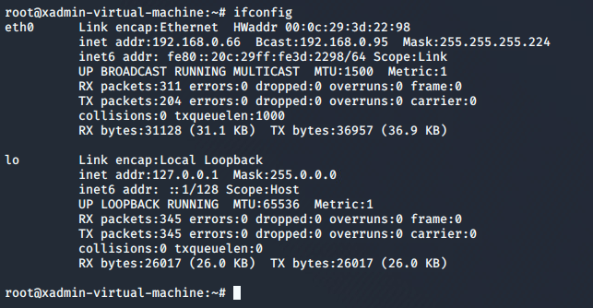Figure 39.3 – ifconfig for pc5

This means that this is the final device on this Router and this Router is the final router in this network , and because of this, this is the conclusion of the network mapping process.

# Security Weaknesses

## Routers

### Default Credentials

Throughout the network evaluation , default credentials are being used to sign into the VyOS operating system that the routers are running. As these credentials are publicly available , this causes an issue especially if a bad actor were to gain access to the internal network it would be easy for them to gain further access to the router themselves.

#### Mitigation

The best way to mitigate this issue is to change the credentials of any device that ACME Inc acquires that has default credentials to something more secure. This should have a unique username and a suitable strong password which should employ upper- and lower-case letters, numbers and special characters. This can be done in VyOS by using these commands :

* Change username – sudo usermod -l [new-name] [old-name]
* Change Password: If logged in – passwd , if logged in to another account – sudo passwd [username]

### Telnet

To be able to gain access to the routers the telnet protocol is being used, any information that is being passed through telnet is unencrypted and this can be monitored and understood by a bad actor by using a packet sniffer attack. This can include username, passwords and any other potential sensitive data that could pass through a router at any given time.

#### Mitigation

The best way to mitigate this is, is if any remote access is needed, to disable the telnet protocol entirely across the network and replace it with SSH(Secure Shell) , this protocol will function in much the same way from the user’s perspective, but this protocol has the added benefit of data encryption during transfer unlike the telnet which doesn’t.

## Computers

### Weak Passwords

It was found throughout this investigation of the network that the passwords that were being used on certain user devices were very inadequate. These passwords are as follows : plums,!gatvol,apple,pears and root. They are very short in length, and they vary very little in the character set. One of the more problematic passwords is the “plums” password due to it being a dictionary word with no alphanumeric variation ( upper case characters, numbers , no special characters etc.). This can result in many dictionaries and wordlists containing this word. In addition to this , even a password that seems stronger like “!gatvol” which does contain special characters is still weak and , as some password wordlists order passwords alphanumerically with special characters coming up first.

#### Mitigation

The best solution to this issue is to create stronger passwords and to implement a password policy. The Canadian Centre for Cyber Security recommends using a minimum of 12 characters (Security, 2024) as well as passphrases which are easier to remember and the chance of them being in a wordlist for a dictionary attack is lower. Passwords should also be case-sensitive and implement the use of certain special characters/numbers. Also to not use easy to guess passwords like (“password”,”admin”) instead use hard to guess passwords. Make sure to have varied character types – uppercase, lower case , numbers and symbols in your passwords. Avoid obvious character substitutes 3 for e , 0 for o etc.

### Password Reuse

In this investigation it was found that PC1 and PC 2 were both using the same password “plums” , for the xadmin accounts on their respective devices. Which combined with the simplicity of the password , poses a security concern.

#### Mitigation

It would be recommended that each account on each device have separate passwords , as this will prevent any malicious actors from being able to gain access to multiple sections of the network using the same or very similar credentials.

### No Lockout Policy

During this investigation , WPScan was used on WordPress for a dictionary attack to obtain user passwords (section 3.1.1). This attack is carried out by trying various passwords from a given wordlists against a target. This attack was successful due to the lack of a lockout policy which would prevent numerous incorrect logins attempts in short succession.

#### Mitigation

The best way to mitigate this from happening would be to implement a lockout policy. These can be implemented on SSH and WordPress to stop this from happening. For SSH this can be done by editing the sshd_config file , by specifying the amount of incorrect login attempts are allowed. For WordPress (Balkhi, 2024) a lockout mechanism can be implemented with a plugin as well as a Captcha can be configured to be able to combat any automated login attempts.

### SSH Brute Forcing

The Default SSH settings allow a user to attempt to login an arbitrary number of times without any restrictions. During this test, this was used with great effect using Metasploit’s ssh_login brute forcing module, which allowed the tester to login by conducting a dictionary based brute force attack.

#### Mitigation

To mitigate this issue would be to configure a lockout mechanism in the /etc/pam.d/ssh and then alter the value of the deny and unlock_time attributes. The former will set a maximum number of failed attempts before the user is locked out , and the latter will specify an amount of time in seconds before it is locked.

### NFS Privileges

In several cases in this investigation, it was possible to use NFS as shown on PC 1 and PC5 and it was possible to read the entire filesystem through NFS as seen in sections 3.1.2,3.3.1 and 3.5.1. This allowed access to files such as /etc/passwd and /etc/shadow and for user credentials to be obtained from these.

It was also possible to move specially crafted SSH keys from their device to the targets through this process and then gain access to said device.

#### Mitigation

To be able to mitigate these issues , reconfiguring what is being shared and what operations can be performed on these files. It should be avoided sharing entire filesystems to avoid exposing sensitive information and having files modified by a threat actor to gain persistence , this can include editing authorized SSH keys. A best practice for NFS is to have separate shared directories for files that are intended to be shared. The files need to have the least possible permissions necessary – if users only need to read a file , it shouldn’t have write permissions enabled. Also, filesystems should be exported explicitly for the users that have access to it, this should avoid unauthorized access to the filesystems. To be able configure NFS , it can be done in /etc/exports file.

### Misconfigured Superuser Permissions

Sometimes superuser permissions are required, the way it is configured on this network poses a big security problem. A potential threat actor can obtain these privileges by using the command sudo su on every PC where the initial access was made with a non-root account.

#### Mitigation

To be able to mitigate this , is to evaluate if users on the network need full access to the machine with su. It is possible to configure the sudoes file so that regular users are not able to use the su command. It should only be commands that are deemed essential for the user to access that should use sudo , such as updating the PC’s , if the update is company approved.

## Servers

### Out Of Date WordPress Version

On Web Server 1 , the version of WordPress is severely out of date. This is an issue as the server could be vulnerable to any number of exploits which can range from mild to severe. A vulnerability in this range was used by the tester to gain access to the admin password.

#### Mitigation

To be able to fix this issue , is to simply upgrade WordPress to the most recent and stable version and to implement frequent patching when new versions come out. This will mitigate the issue by removing all widely known vulnerabilities from this software.

### Out of Date Apache Version

The Apache Web Servers are also running an out-of-date version of the Apache web hosting software, which is dangerous for the same reasons as stated in the above section 4.3.1.

#### Mitigation

As stated in section 4.3.1.1 , the best way to mitigate these issues is to update to the most recent and stable version and implement frequent patching when a new version comes out.

### Shellshock

Webserver 2 was shown to be vulnerable to the Shellshock vulnerability which is a remote code execution vulnerability in Bash. In this investigation it was shown that the /cgi-bin/status directory is vulnerable and was exploited to gain access to the system in section 3.4.

#### Mitigation

There are 2 ways to mitigate this vulnerability. The first method which is the simplest method of mitigation is to simply update bash to a version that will prevent this issue, this can be done by using the command “sudo-apt-get -only-upgrade install bash” and/or “sudo apt-get updated && sudo apt-get upgrade” , with the former being used if bash is the only program being updated and the latter to update the entire system.

The second method is a bit more complex. There is a possible way to configure Apache to prevent external access to the /cgi-bin/status directory , which as this is the only area the vulnerability is in , this option is more suitable if updates could break the system. Also, if the file/directory is required for normal functioning of the website , it is possible that the Apache instance can be configured to prevent any external access but will still allow access to the file/directory via localhost.

## Firewall

### Default Credentials

As was shown in section 3.4 , the firewall software pfsense is in use on this network and it makes use of default credentials in this case “admin/pfsense”.

#### Mitigation

As was written in section 4.1.1 , the recommended action is to change the credentials which in pfsense can be done by going into system and then user manager. The recommendations from section 4.2.1.1 and 4.2.2.1 are the same for new passwords.

### HTTP vs HTTPS

To access the pfsense web GUI , the protocol that is used is HTTP , this is an insecure protocol as any content sent over this protocol is not encrypted using SSL which can allow an malicious actor to perform a man-in-the-middle attack and then view the unencrypted content sent over this protocol which can include but is not limited to credentials and critical information which can pertain to the network’s configuration.

#### Mitigation

The best way to mitigate this is to switch from using HTTP to HTTPS(Hyper Text Transfer Protocol Secure) , to be able to do this is to go into the pfsense web GUI system and then into Advanced and tick the box that says HTTPS(SSL/TLS). There can also be further configuration which can be found in various menus and their submenus.

# Discussion

## Evaluation of Network

### Topology

The main concern regarding the design of this network is that it’s a linear topology, this design is affordable and simple to install however it also poses several disadvantages that are outweighed by the low cost and the simplicity. The first issue with this layout is that if any part of the network goes down, certain areas of the network would not be able to communicate as there are no alternative routes that could be used on the network if parts are dysfunctional. Network downtime leads to loss of profit for companies, which means any cost savings from a cheaper network design is ultimately negligible. Additionally, for two hosts on either end of the network to communicate, the traffic must pass across the entire network. This leads to network congestion and increased latency; this would be most noticeable in Router 2 and Router 3 as they are located at the centre of the network. A solution to this, for this network would be to adopt a loop-like topology by connecting Routers 1 and 3 to form a ring. This design would allow for redundancy for the network as well as ensuring alternate routes for traffic in the event of a node failure. This will also reduce latency in certain scenarios, as the distance between two distances will be shorter for example, only one network segment would separate Router 1 and Router 3.

### Routing

The routing tables of each router has revealed that OSPF routing protocol has been configured. The protocol allows for the routing information to be exchanged between neighbouring routers, allowing them to build a topology map of the network. This map is then used to calculate the end-to-end paths using a variation of Dijkstra’s shortest path algorithm. Using the OSPF is considered good practice as it ensures efficient routing is done. This network currently lacks a design with multiple route options, however if the above changes to the network design are implemented the OSPF would detect these changes and then calculate the new routes. It would also detect network outages and recalculate the routing information accordingly to then redirect the traffic. (Awati, n.d.)

### Subnetting

This network shows an efficient use of VLSM in some areas. The subnets between Routers 1 to 3, the Firewall and Webserver 2 have been properly configured with a netmask of 255.255.255.252 or /30. These subnets are smaller segments of the 192.168.0.224/27 subnet, this allows only 2 hosts in each subnet, which is ideal for links between two hosts. Having only two usable IP addresses, both in use, the network avoids wasting IP addresses. This approach should also be applied to the subnet between the Firewall and Router 4, which is currently using the 192.168.0.96/27 subnet, this subnet allows for 30 usable hosts, which only 2 are in use as it connects the router and a firewall. It is recommended to use the 192.168.0.236/30 subnet instead which is currently unused and is also part of the 192.168.0.224/27 range that has been used for subnets with 2 hosts. Another issue with the subnetting is that most of the subnets are using a 255.255.255.224 netmask which allows for 30 usable hosts, while only two are used. While leaving unused IP addresses for company expansion is good practice, this current setup leaves 138 unassigned addresses, it is suggested to consider using smaller subnets like the /29 which allows for 6 usable hosts. This would economise address space and would provide space for more additional subnets to be added in the future or space to be used for current existing ones which are unnecessary large like 13.13.13.0/24 with VLSM. Furthermore the 13.13.13.0/24 subnet is in public IP range and has 252 unused addresses. This isn’t a major issue but if internet access is needed on this subnet, this could pose a risk of conflicting with an IANA assigned host with this IP address. (Wright, 2003) It is recommended to use smaller subnets with fewer hosts and if internet connectivity is required a different address should be used. Lastly, the subnet containing Webserver 1 is also unnecessary large with 252 unused addresses, it is recommended to use a smaller subnet with fewer usable hosts in this case as well.

### Components

In this network the use of the firewall was good however it was rendered nearly useless by the security flaws in the devices it was connected to. The firewall rules were configured to allow access from the WAN only to Webserver 2 in the DMZ and to permit access from the Webserver solely to PC5 rather than both the PC5 and Router 4. This configuration means that the LAN would not be fully accessible if PC5 was compromised and changes to the firewall rules to gain further access to the network. Similarly, PC5 would have been unreachable if the Webserver was not vulnerable. In this assessment the firewall only slowed down the investigation but did not prevent it which would have been the case if the device security was stronger.

Another advantage of this network is that both Webservers are standalone entities in their subnets, this setup allows dedicated bandwidth to the server’s switch port using asymmetric switching which prevents bottlenecking. With this result, traffic flow remains smoother when multiple clients communicate with a server simultaneously. (Haider, 2013)

The setup for PC2 and PC3 to the router and each other could be improved, as these PCs are currently wired PC3 can not communicate with the rest of the network if PC2 is offline. Adding a switch would allow the ethernet signal to be split to ensure consistent connectivity, however this improvement is not strictly necessary if PC3 is not intended to communicate with the rest of the network as its subnet does not appear in any other router’s routing information. If this isolated configuration is intentional, then no changes are required.

## Further Work

Further work for this network would be that once the new network administrator has made the relevant changes to the network, a follow up network assessment be done in the same vein as this one so that any issues that may have been missed or have appeared due to the reconfiguration of this network can then be fully assessed.

Another would be to add additional firewalls which would be beneficial. It is advised by NIST to add a main border firewall at the edge of a logical Network boundary which will act as a first line of defense which will protect the internal company network from any external threats. In routed networks ,this firewall is typically positioned just before external traffic reaches an internet-facing router. This setup enables any public-facing services to be hosted within the firewall's demilitarized zone (DMZ). (Guidlines on Firewalls and Firewall Policy, 2009)

Another good addition to this network would be an Intrusion Detection System(IDS). This would provide an additional layer of security , by monitoring the network for any signs of intrusion. This can be placed inline or out of bounds, the placement depends on the resources available.

To implement it inline requires it to be powerful to handle incoming traffic efficiently as to not create any bottlenecks while implementing out of bounds would mean that it would only detect any intrusions after the fact were as inline detects intrusions on time. It is recommended to deploy an IDS behind the firewall on the edge of the network which will give the highest visibility and will focus on the traffic leaving or entering the private network. With the size of this network being on the smaller end it would be more beneficial to use an inline IDS , implementing it would add security to the network as the company would be able to have insight into what is happening in the network. Having an additional IDS could be used to cover internal traffic, however that is not urgent and will again depend on the resources available.

# Conclusions

In conclusion there are some good practices in place regarding the overall design of this network , such as the uses of VLSM, firewall and OSPF among others but there are still multiple areas of the network that need to be improves on. One of the main issues is the topology of the network being inefficient and the subnets having a lot of unused addresses. A way to address this is to use VLSM more efficiently to create smaller subnets and assign unused subnets to areas of the network instead of using a network from an entirely different IP range. This network would also benefit from an IDS(Intrusion Detection System).

There is numerous security issues present on this network which have allowed every host to be compromised in some way, these are easy to mitigate by updating software, changing default credentials and enforcing a password policy within the company. There are other vulnerabilities that can be fixed managing the services used , for example configuring a lockout policy for SSH and WordPress Services as well as configuring NFS to not share sensitive information.

The overall state of this network is highly insecure and the actions that are put forth in Section 4 should be implemented immediately.

Moving forward, it is suggested to implement the recommendations detailed in Section 5 to further improve the network's security, efficiency, and functionality.

# References

Anantapatnaikuni, S. (n.d.). *FAQs*. Retrieved from VyOS Support Portal: https://support.vyos.io/support/solutions/articles/103000089938-faqs

Awati, R. (n.d.). *Open Shortest Path First (OSPF)*. Retrieved from TechTarget: https://www.techtarget.com/searchnetworking/definition/OSPF-Open-Shortest-Path-FirstRahul Awati

Balkhi, S. (2024, 9 9). *How and Why You Should Limit Login Attempts in WordPress.* Retrieved from wpbeginner: https://www.wpbeginner.com/plugins/how-and-why-you-should-limit-login-attempts-in-your-wordpress/

*Guidlines on Firewalls and Firewall Policy.* (2009, 9). Retrieved from NIST: https://nvlpubs.nist.gov/nistpubs/legacy/sp/nistspecialpublication800-41r1.pdf

Haider, A. (2013, 10 17). *Symmetric and asymmetric switching / Memory buffering*. Retrieved from CCNA :) Be a Good Network Administrator: https://basicitnetworking.blogspot.com/2013/10/symmetric-and-asymmetric-switching.html#:~:text=Asymmetric%20switching%20enables%20more%20bandwidth,required%20on%20an%20asymmetric%20switch.

Security, C. C. (2024, 02). *Best practices for passphrases and passwords (ITSAP.30.032).* Retrieved from Canda.ca: https://www.cyber.gc.ca/en/guidance/best-practices-passphrases-and-passwords-itsap30032

Staff, A. (2022, January 21). *Five Most Famous DDoS Attacks and then some*. Retrieved from A10 : https://www.a10networks.com/blog/5-most-famous-ddos-attacks/

VyOS. (n.d.). *Getting Started*. Retrieved from OrionVM Documentation : https://docs.orionvm.com/vyos/getting-started/

Wright, D. R. (2003). *Practical TCP/IP and Ethernet Networking for Industry.* Oxford: Newnes.

# Appendices

## Appendix 1 Subnetting Working

Method:

This is the method that was used to be able to calculate the subnets in the network.

1. If the network address was not present in the routing information obtained during the network evaluation process are calculated by performing AND operations with the IP Address and the Netmask in their binary forms.
2. The Host bits are represented by 0’s in the binary form of the netmask
3. The total addresses are calculated with the formula 2host bits, while the usable addresses are decreased by the number 2.
4. The Broadcast address is calculated by adding the total address number to the network address, keeping in mind that the network address is already the first address used in the subnet.
5. The Host Range is the addresses that are between the network and broadcast addresses.

13.13.13.0/24

|  |  |
| --- | --- |
| IP Address on the network(Decimal) | 13.13.13.12 |
| Used netmask(Decimal) | 255.255.255.0 |
| IP Address(Binary) | 00001101.00001101.00001101.00001100 |
| Netmask(Binary) | 11111111.11111111.11111111.00000000 |
| Network Address(Binary) | 00001101.00001101.00001101.00000000 |
| Network address(Decimal) | 13.13.13.0 |
| Host Bits | 8 |
| Total Addresses | 28 = 256 |
| Usable Addresses | 256-2=254 |
| Broadcast Address | 13.13.13.255 |
| Host Range | 13.13.13.1-13.13.13.254 |

172.16.221.0/24

|  |  |
| --- | --- |
| Netmask(Decimal) | 255.255.255.0 |
| Netmask(Binary) | 11111111.11111111.11111111.00000000 |
| Network address(Decimal) | 172.16.221.0 |
| Host Bits | 8 |
| Total Addresses | 28 = 256 |
| Usable Addresses | 256-2=254 |
| Broadcast Address | 17.16.221.255 |
| Host Range | 172.16.221.1-172.16.221.254 |

192.168.0.32/27

|  |  |
| --- | --- |
| Netmask(Decimal) | 255.255.255.224 |
| Netmask(Binary) | 11111111.11111111.11111111.11100000 |
| Network address(Decimal) | 192.168.0.32 |
| Host Bits | 5 |
| Total Addresses | 25= 32 |
| Usable Addresses | 32-2=30 |
| Broadcast Address | 192.168.0.63 |
| Host Range | 192.168.0.33-192.168.0.62 |

192.168.0.64/27

|  |  |
| --- | --- |
| Netmask(Decimal) | 255.255.255.224 |
| Netmask(Binary) | 11111111.11111111.11111111.11100000 |
| Network address(Decimal) | 192.168.0.64 |
| Host Bits | 5 |
| Total Addresses | 25=32 |
| Usable Addresses | 32-2=30 |
| Broadcast Address | 192.168.0.95 |
| Host Range | 192.168.0.65-192.168.0.94 |

192.168.0.96/27

|  |  |
| --- | --- |
| Netmask(Decimal) | 255.255.255.224 |
| Netmask(Binary) | 11111111.11111111.11111111.11100000 |
| Network address(Decimal) | 192.168.0.96 |
| Host Bits | 8 |
| Total Addresses | 28=32 |
| Usable Addresses | 32-2=30 |
| Broadcast Address | 192.168.0.127 |
| Host Range | 192.168.0.97-192.168.0.126 |

192.168.0.128/27

|  |  |
| --- | --- |
| Netmask(Decimal) | 255.255.255.224 |
| Netmask(Binary) | 11111111.11111111.11111111.11100000 |
| Network address(Decimal) | 192.168.0.128 |
| Host Bits | 8 |
| Total Addresses | 28=32 |
| Usable Addresses | 32-2=30 |
| Broadcast Address | 192.168.0.159 |
| Host Range | 192.168.0.129-192.168.0.158 |

192.168.0.192/27

|  |  |
| --- | --- |
| IP Address on the network(Decimal) | 192.168.0.200 |
| Used netmask(Decimal) | 255.255.255.224 |
| IP Address(Binary) | 11000000.10101000.00000000.11001000 |
| Netmask(Binary) | 11111111.11111111.11111111.11100000 |
| Network Address(Binary) | 11000000.10101000.00000000.11000000 |
| Network address(Decimal) | 192.168.192 |
| Host Bits | 5 |
| Total Addresses | 25 =30 |
| Usable Addresses | 32-2=30 |
| Broadcast Address | 192.168.0.223 |
| Host Range | 192.168.0.193-192.168.0.222 |

192.168.0.224/30

|  |  |
| --- | --- |
| Netmask(Decimal) | 255.255.255.252 |
| Netmask(Binary) | 11111111.11111111.11111111.11111100 |
| Network address(Decimal) | 192.168.0.224 |
| Host Bits | 2 |
| Total Addresses | 22=4 |
| Usable Addresses | 2-2=2 |
| Broadcast Address | 192.168.0.227 |
| Host Range | 192.168.0.225-192.168.0.226 |

192.168.0.228/30

|  |  |
| --- | --- |
| Netmask(Decimal) | 255.255.255.252 |
| Netmask(Binary) |  |
| Network address(Decimal) | 192.168.0.228 |
| Host Bits | 2 |
| Total Addresses | 22=4 |
| Usable Addresses | 2-2=2 |
| Broadcast Address | 192.168.0.231 |
| Host Range | 192.168.0.229-192.168.0.230 |

192.168.0.232/30

|  |  |
| --- | --- |
| Netmask(Decimal) | 255.255.255.252 |
| Netmask(Binary) | 11111111.11111111.11111111.11111100 |
| Network address(Decimal) | 192.168.0.232 |
| Host Bits | 2 |
| Total Addresses | 22=4 |
| Usable Addresses | 2-2=2 |
| Broadcast Address | 192.168.0.235 |
| Host Range | 192.168.0.233-192.168.0.234 |

192.168.0.240/30

|  |  |
| --- | --- |
| Netmask(Decimal) | 255.255.255.252 |
| Netmask(Binary) | 11111111.11111111.11111111.11111100 |
| Network address(Decimal) | 192.168.0.240 |
| Host Bits | 2 |
| Total Addresses | 22=4 |
| Usable Addresses | 2-2=2 |
| Broadcast Address | 192.168.0.243 |
| Host Range | 192.168.0.241-192.168.0.242 |

## Appendix 2 Dirb Scan

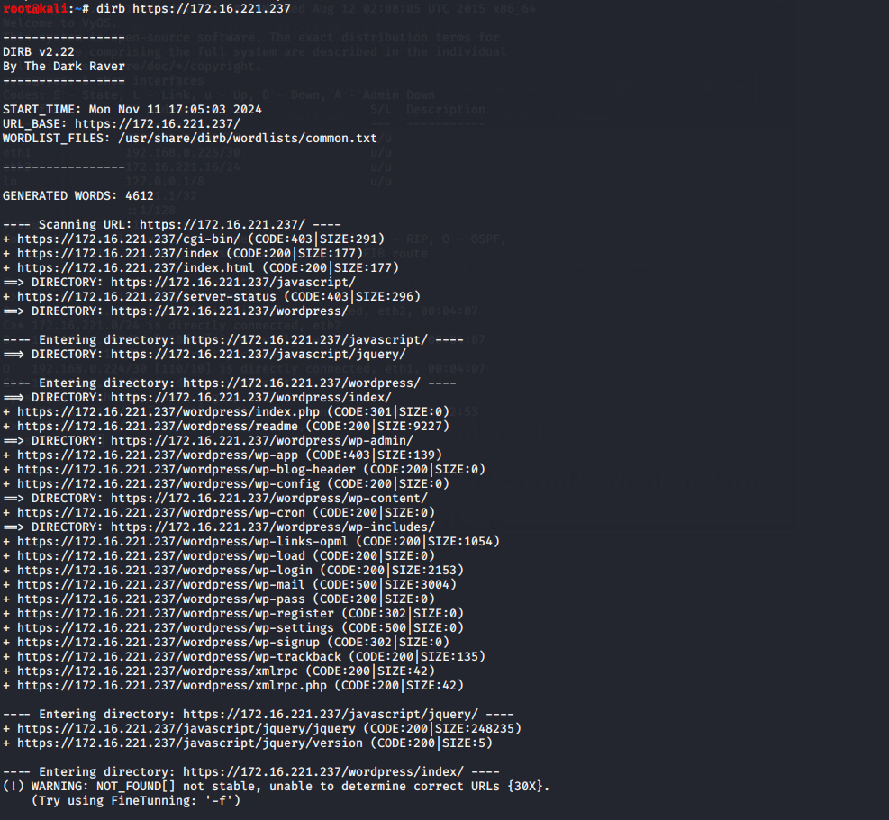

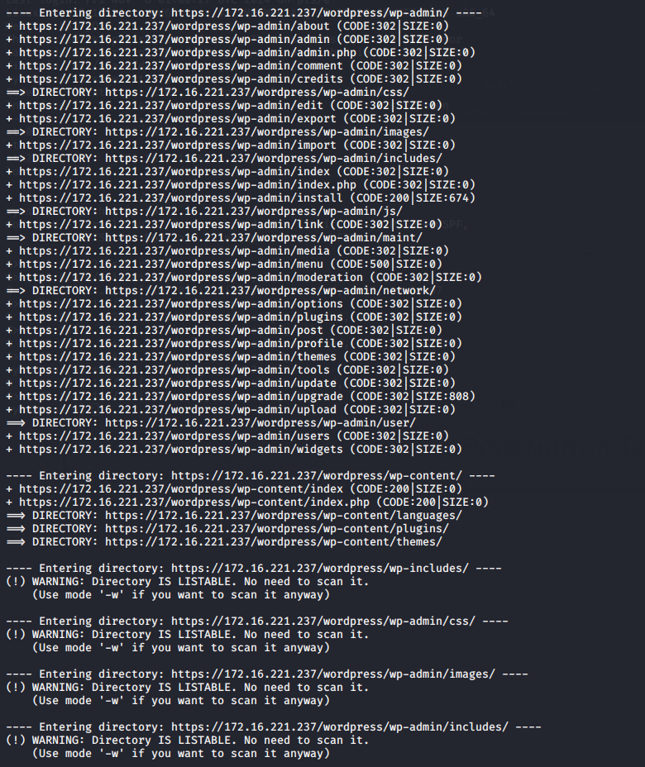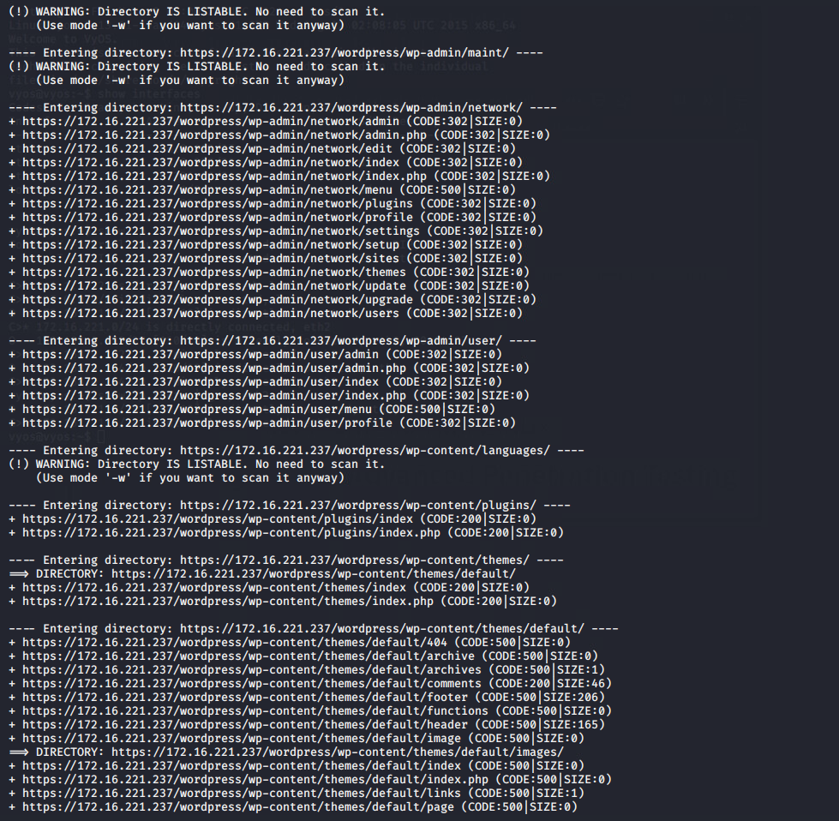

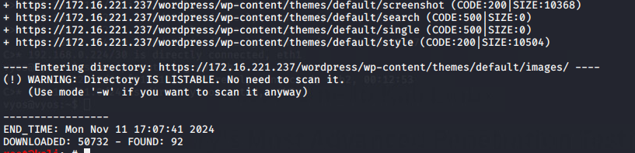

## A black background with white text Description automatically generatedAppendix 3 Nikto Scan

## Appendix 4 WPScan

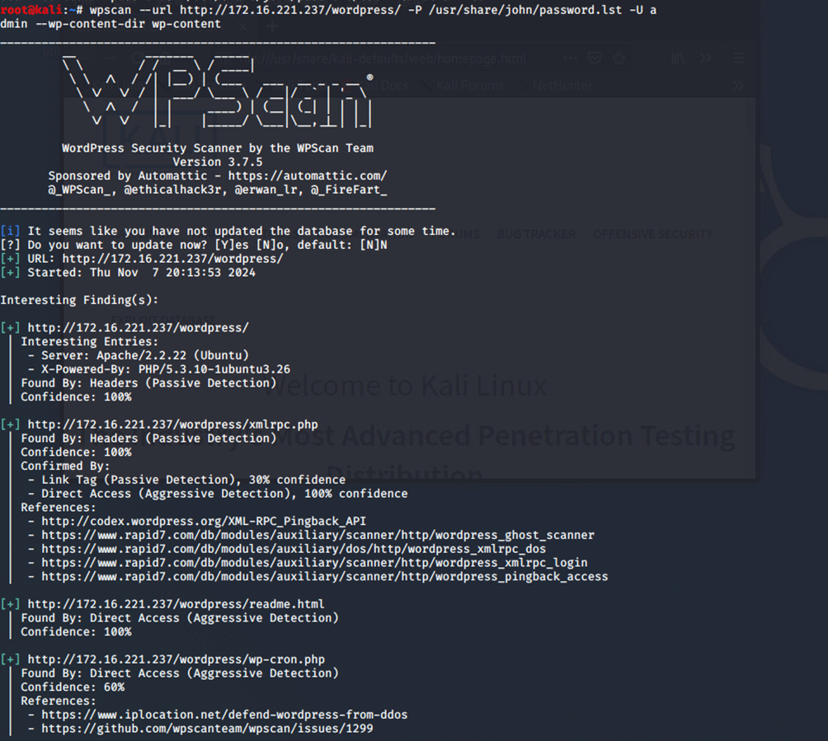

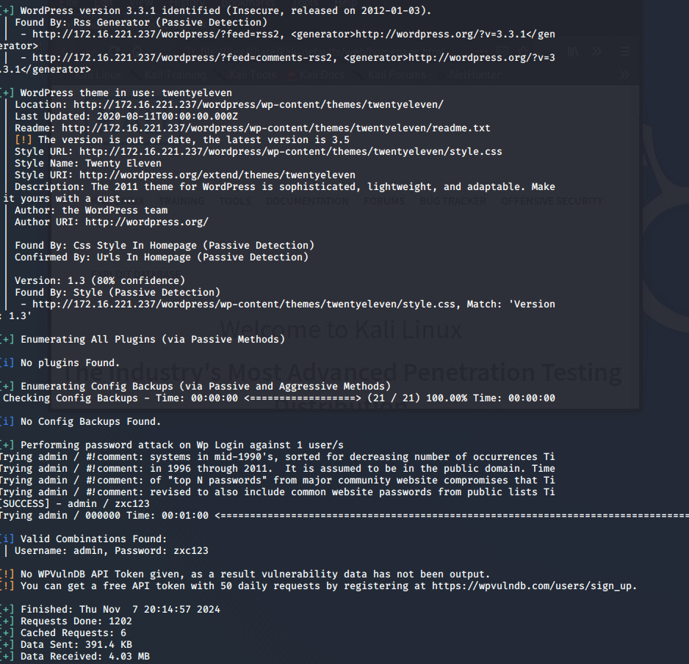

## Appendix 5 Metasploit

Metasploit on 192.168.0.242

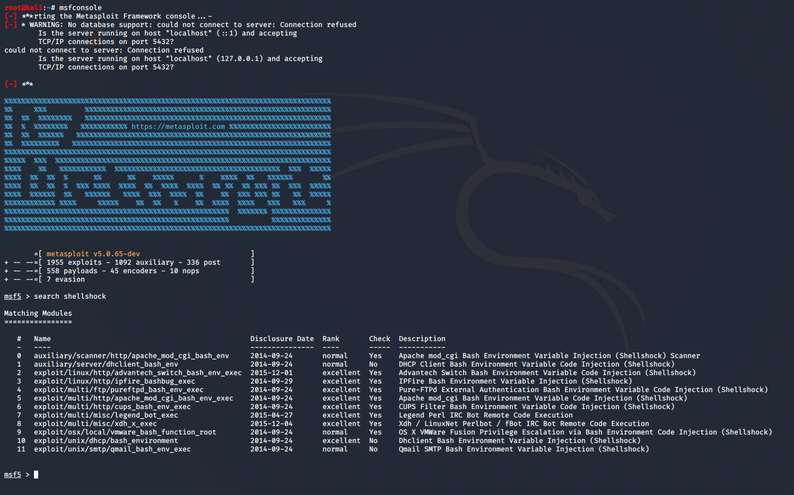

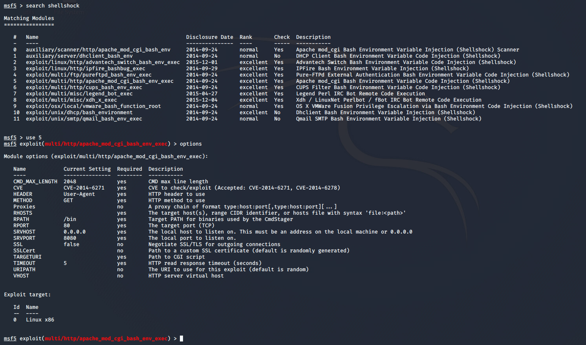

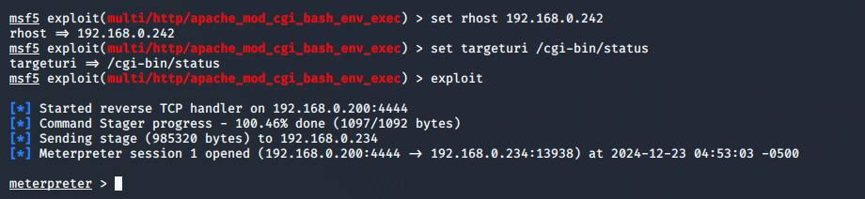

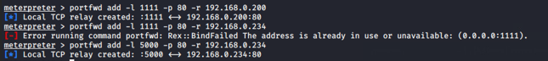





Metasploit for password cracking – 13.13.13.13





## Appendix 6 NMAP Scans

Nmap scan on 192.168.0.192/27

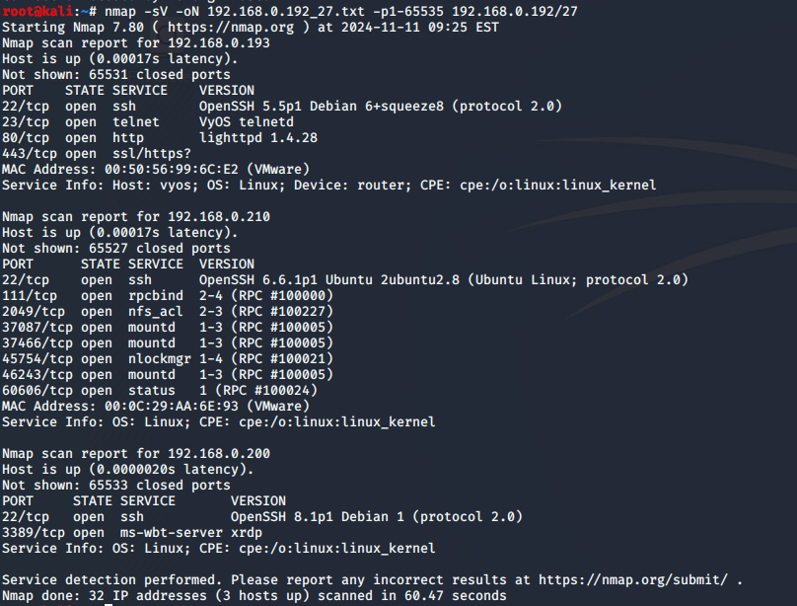

Nmap scan on 192.168.01/24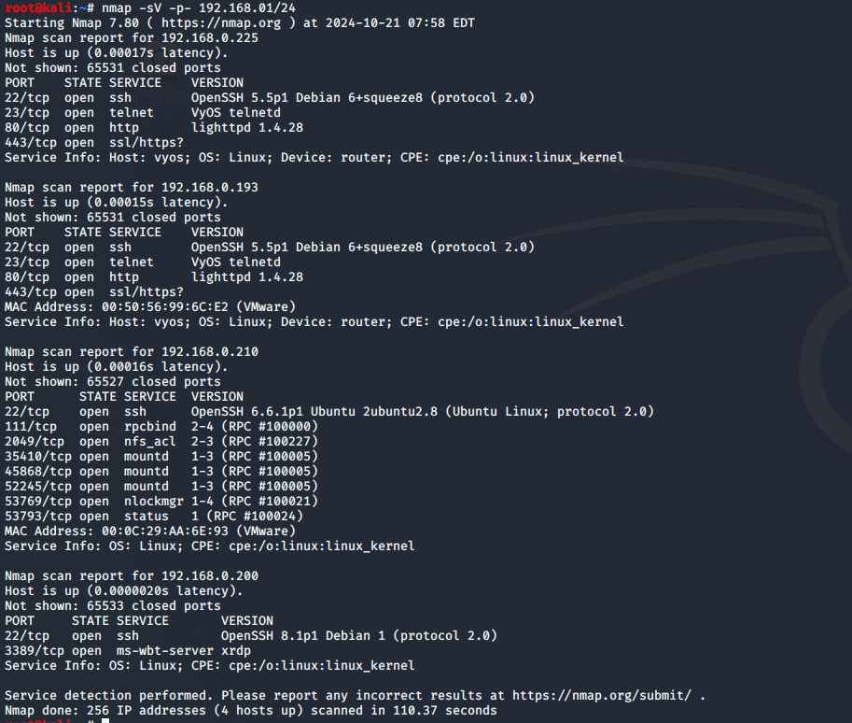

Nmap scan on 192.168.0.200/24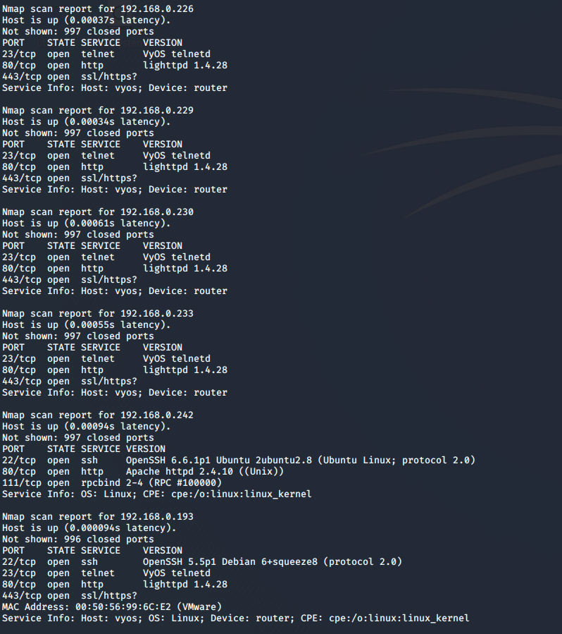

Nmap scan on Router 1

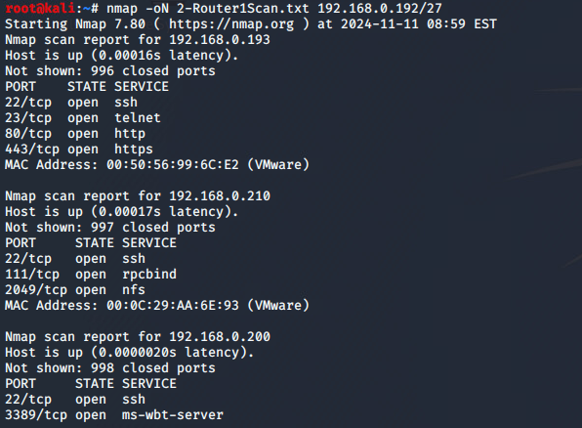

Nmap scan on 172.16.221/16/24

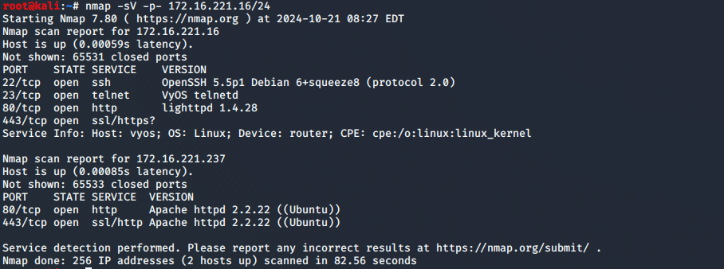

**Nmap scan on Router 2**



**Nmap scan on 192.168.0.33/27**



Router 3





Nmap scan on 192.168.0.232/30

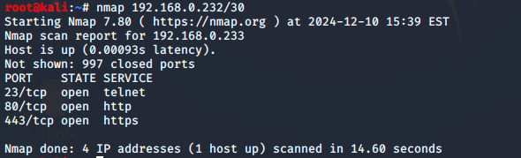

Nmap scan on 192.168.0.128/27 on PC4

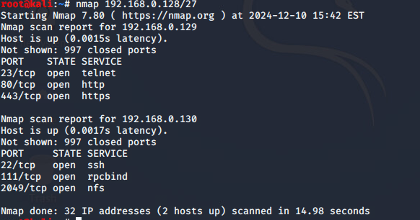



Nmap scan on 13.13.13.13

